"Synergizing Emotional Intelligence and Transformational Leadership: Enhancing Individual and Organizational Effectiveness"

**Abstract**

This study investigates the complex relationship between Emotional Intelligence (EI) and Transformational Leadership, revealing their collective impact on enhancing individual and organizational performance. Through comprehensive statistical analysis, it explores correlations with various demographics such as education, experience, and nationality, providing insight into their interactions with EI and leadership dynamics. The study finds a negative correlation between higher education levels and satisfaction in stress management, along with skepticism towards EI's effectiveness. Similarly, experienced professionals often view EI critically in leadership contexts. These insights highlight the need for demographic-specific EI and leadership training programs. Recommendations include tailored EI development, specialized training for experienced professionals, integration of EI into leadership development, an emphasis on EI in decision-making, global promotion of EI across different nationalities, enhanced stress management in EI training, and the establishment of EI-focused teams. This study advocates for long-term EI integration strategies and continuous evaluation of training programs, affirming the vital synergy between EI and Transformational Leadership for future leadership and organizational growth.

**1. Introduction**

**The Interplay Between Emotional Intelligence and Individual Effectiveness in Organizations**

In the rapidly evolving business landscape, an individual's effectiveness within organizations is often driven by factors beyond mere technical skills or domain knowledge. Among these factors, Emotional Intelligence (EI) has emerged as a prominent predictor of professional success and individual effectiveness[1]. Emotional Intelligence, as defined by[2], encompasses the ability to recognize, understand, manage, and effectively employ emotions in oneself and others. It's not merely about being aware of emotions but also about manoeuvring them to adapt to environments and achieve objectives.

Research over the past few decades has consistently underscored the significance of EI in workplace settings. For instance, a study by [3] illustrated that employees with higher levels of emotional intelligence were better equipped to handle workplace challenges, fostered greater collaboration, and were often more adaptable to change. This, in turn, made them more effective in their roles, and they contributed positively to their organizations. Such findings align with the views of experts who believe that individual effectiveness in organizational contexts is not merely about the tasks one performs but also about how one interacts, communicates, and collaborates with others[4].

While the direct relationship between EI and individual effectiveness is evident in isolated studies, a holistic analysis within varied organizational contexts remains a gap in the literature. This research aims to bridge that gap, delving deeper into the nuances of this relationship and shedding light on how Emotional Intelligence shapes individual outcomes in diverse organizational settings.

**The Confluence of Emotional Intelligence and Transformational Leadership**

The concept of leadership has undergone significant transformations over the years, with diverse styles emerging and getting adapted to different organizational paradigms. Among the many leadership styles, Transformational Leadership, first introduced by [5], stands out for its emphasis on inspiring and motivating employees to exceed their own limitations and achieve extraordinary results. Transformational leaders don’t just lead; they elevate those around them, creating environments where innovation, creativity, and commitment thrive.

The relevance of Emotional Intelligence in the context of Transformational Leadership is a domain garnering considerable interest. [6] posited, transformational leaders often demonstrate high levels of emotional intelligence, enabling them to resonate with their followers' emotions, drive positive change, and achieve common organizational goals. The ability of these leaders to understand and regulate their own emotions, empathize with team members, and use these insights to direct group dynamics is a testament to the intricate blend of EI and transformational leadership practices.

[7] further demonstrated that leaders who underwent emotional intelligence training displayed increased transformational leadership behaviors. This intersection of EI and transformational leadership is not just theoretical; organizations are actively seeking to harness its potential benefits. Integrating EI with transformational leadership could potentially lead to better decision-making processes, enhanced team dynamics, and ultimately, superior organizational outcomes. This research seeks to evaluate these benefits and understand the tangible impacts of this integration in real-world workplace settings.

**Practical Implications for Organizations: Harnessing Emotional Intelligence and Transformational Leadership**

In the corporate realm, theory and practice often intersect. As we navigate through the importance of Emotional Intelligence and Transformational Leadership individually, the pragmatic implications of these combined concepts for organizations cannot be overlooked. As competition intensifies and organizations grapple with unprecedented challenges, the quest for strategies to enhance performance becomes paramount.

Merging the principles of Emotional Intelligence with Transformational Leadership offers a compelling strategy. [8] argued that organizations can reap substantial benefits by fostering an environment where EI is recognized, valued, and developed. Such environments are likely to witness improved team dynamics, reduced conflict, and increased adaptability in the face of change. When complemented with transformational leadership, this environment further amplifies innovation, drives engagement, and fosters a sense of collective purpose.

Drawing from both empirical studies and real-world applications, there's an evident need for a structured guide that assists organizations in implementing these principles. [9] pointed out that leaders with high emotional intelligence are more likely to cope with organizational demands, provide clarity in chaotic situations, and guide teams with empathy and vision. Building on this understanding, this research will not only elucidate the benefits of combining EI and Transformational Leadership but also offer actionable insights. These practical tips aim to equip organizations with tools and methodologies to seamlessly integrate these principles, optimizing team and overall performance.

**2. Background of the Study**

**The Emergence and Evolution of Emotional Intelligence**

Emotional Intelligence (EI) is not a novel concept, although its significance in organizational contexts has gained traction in recent decades. Historically, the traditional measure of intelligence, or IQ, dominated academic and workplace arenas. However, there was a growing recognition that cognitive intelligence alone did not account for individuals' life and career successes [10]. It was evident that other factors, particularly relating to understanding and managing emotions, played crucial roles in individuals' achievements.

Mayer and Salovey's work in the early 1990s marked a significant shift in understanding EI as a structured concept. They defined EI as the capacity to reason about emotions and use emotions to enhance thinking [2]. This framework emphasized the importance of perceiving, using, understanding, and managing emotions. Over time, this model has been refined and expanded upon by various researchers.

[1] seminal book on emotional intelligence popularized the concept, asserting that EI can be as crucial, if not more so, than IQ in determining professional and personal success. Goleman expanded on Mayer and Salovey's model, incorporating aspects related to motivation, empathy, and social skills. The implications of Goleman's findings for organizational behavior and leadership studies were profound, leading to a surge in research investigating the role of EI in workplace dynamics, leadership, and team performance.

**Transformational Leadership: A Paradigm Shift in Leadership Styles**

Leadership, as a concept, has been dissected, analyzed, and redefined throughout history. From autocratic leadership styles, where control and authority were central, we have seen a shift towards more inclusive, motivational, and collaborative leadership approaches. It was during this evolving understanding of leadership that [4] introduced the idea of 'transformational leadership', which he distinguished from transactional leadership.

Transformational leadership goes beyond the simple exchange mechanisms of transactional leadership, where leaders exchange rewards for performance. Instead, transformational leaders inspire and challenge their followers to achieve a collective vision, promoting innovation, creativity, and personal growth [11]. Such leaders tend to be visionaries who can shape the culture of an organization and leave lasting impacts.

The relevance of transformational leadership in diverse organizational settings became evident. Research indicated that transformational leadership could lead to higher levels of satisfaction, performance, and organizational commitment among employees[12]. This type of leadership was no longer seen as just a theoretical construct but as a tangible tool organization could leverage to drive significant positive change.

The potential synergies between transformational leadership and emotional intelligence began to be explored in the early 2000s, culminating in studies that demonstrated how EI competencies could further enhance the effectiveness of transformational leaders [13].

**The Intersection of Emotional Intelligence and Leadership in Organizational Performance**

While the significance of both Emotional Intelligence and Transformational Leadership was individually acknowledged in organizational settings, it was the convergence of these two paradigms that offered a promising avenue for enhancing workplace outcomes. The rationale behind blending these domains stems from the understanding that effective leadership is not just about vision and strategy; it's also about understanding, connecting with, and motivating a diverse group of individuals.

[14] suggested that leaders with high levels of emotional intelligence were better equipped to inspire, influence, and drive organizational success. This was attributed to their ability to perceive and understand the emotional undercurrents of their teams, thereby addressing concerns, leveraging strengths, and fostering a cohesive work environment.

Transformational leaders, given their propensity to connect with their team's aspirations and potential, naturally aligned with the tenets of emotional intelligence. This alignment meant that transformational leaders, when armed with high EI, could more effectively mobilize teams, encourage innovation, and achieve superior results. This alignment became even more crucial in dynamic environments, where change was a constant, and adaptability and resilience were imperative [15].

For organizations, understanding this intersection was not just about improving leadership effectiveness; it was about holistic organizational growth. Teams led by leaders proficient in both EI and transformational leadership techniques reported higher levels of job satisfaction, reduced turnover, and increased productivity[16]. Thus, the integration of Emotional Intelligence with Transformational Leadership emerged as a strategic imperative for forward-thinking organizations.

**Problem statements**

This thesis addresses a significant gap in understanding the intersection between Emotional Intelligence (EI) and Transformational Leadership in the workplace. Despite extensive research on both concepts separately, there is limited insight into how their integration impacts organizational outcomes. The problem is twofold: firstly, to determine whether blending EI with Transformational Leadership approaches can positively influence employee engagement, productivity, and organizational culture; and secondly, to identify the challenges and limitations of implementing this hybrid leadership model in diverse workplace settings

**Research Questions**

The following are the research questions outlined based on the Aims and Objectives of the research:

1. How does Emotional Intelligence directly correlate with individual effectiveness within organizational contexts?
2. In what ways does the combination of Emotional Intelligence and Transformational Leadership benefit workplace dynamics and organizational efficiency?
3. Which attributes or components of Emotional Intelligence are observed to enhance the effectiveness of Transformational Leadership in the corporate sphere?
4. What practical recommendations or strategies can organizations adopt to foster Emotional Intelligence and Transformational Leadership principles to elevate their team's or overall performance?

**Scope of study**

planning to have study is confined to an in-depth exploration of how Emotional Intelligence (EI) and Transformational Leadership, when combined, impact workplace dynamics. It entails an empirical analysis to assess their influence on employee engagement, productivity, and organizational culture. This investigation will be conducted across a variety of organizational settings in different industries, offering a broad perspective on the applicability and effectiveness of this integrated leadership model. The research will also involve a comparative evaluation of traditional and EI-Transformational leadership models, aiming to discern their unique contributions and limitations within the context of modern organizational practices.

**significance of the study**

This study is significant as it offers novel insights into the combined effect of Emotional Intelligence (EI) and Transformational Leadership on organizational dynamics. It underscores the potential for enhanced leadership strategies that improve leader-follower relations and decision-making. The research is pivotal in understanding how this integrated leadership model can boost employee engagement, productivity, and job satisfaction, thereby contributing to overall organizational success. Additionally, it highlights the cultural and ethical benefits of EI in fostering an inclusive workplace. The findings are anticipated to guide the development of effective leadership training programs and set a new direction for future research in organizational behaviour.

# Literature of review

Cavazotte, Moreno, & Hickmann (2012), the nexus between key individual differences such as intelligence, personality traits, and emotional intelligence, and their influence on transformational leadership and managerial performance. Their findings suggest that leadership effectiveness is not only a function of transformational behaviors but is also indirectly influenced by the individual attributes of leaders, such as their experience, cognitive abilities, and conscientiousness. These personal characteristics impact leadership effectiveness through the mediating role of transformational leadership behaviors. This study contributes to the understanding of how intrinsic leader qualities can be harnessed and developed to enhance transformational leadership effectiveness, which is crucial for successful management.

Hur, Berg, & Wilderom (2011), the role of transformational leadership as a mediator in the relationship between emotional intelligence and team outcomes. The study demonstrates that transformational leadership acts as a conduit for the effects of emotional intelligence on leader effectiveness and the service climate of teams. This mediation suggests that leaders with high emotional intelligence are likely to engage in transformational leadership behaviors, which in turn positively affect their team's performance and service climate. The findings provide valuable insights for organizations on the importance of nurturing emotional intelligence in leaders to foster an environment where transformational leadership can thrive and drive positive outcomes.

Ugoani (2015), the KICS Model of Motivational Leadership, which integrates the concept of emotional intelligence competencies within leadership. The model posits that knowledge, intelligence, collaboration, and synergy are fundamental components that underpin motivational leadership behavior. Ugoani's research emphasizes the synergy between these components, suggesting that when leaders are knowledgeable, emotionally intelligent, collaborative, and able to create synergy, they are more likely to inspire and motivate their teams effectively. This model offers a comprehensive approach to understanding and developing leadership qualities that are pivotal for motivation and positive organizational behavior.

Brown & Moshavi (2005), the potential relationship between emotional intelligence and transformational leadership and their combined impact on individual and organizational outcomes. Their study raises critical points about the need for clarity in defining and measuring emotional intelligence and transformational leadership, as well as addressing the psychometric independence of these constructs. The research suggests that while there appears to be a link between emotional intelligence and transformational leadership, further investigation is required to resolve existing issues and understand the true nature and implications of this relationship.

Zaki, Shabib, & Manzoor (2012), investigate how leaders' emotional intelligence influences transformational leadership and its subsequent impact on organizational outcomes. The study finds that components of emotional intelligence are positively associated with transformational leadership qualities. This relationship suggests that leaders who possess higher levels of emotional intelligence are more likely to exhibit transformational leadership behaviors, which can lead to improved organizational performance. The research highlights the significance of emotional intelligence as a critical leadership trait that can enhance the effectiveness of transformational leaders within an organization.

Scott-Halsell, Shumate, & Blum (2007), a model that establishes a direct link between the domains of emotional intelligence and transformational leadership in the hospitality industry. The study emphasizes the need for emotional intelligence instruction in leadership training programs within this sector. Recognizing that the hospitality industry relies heavily on customer service and interpersonal interactions, the research suggests that enhancing leaders' emotional intelligence can significantly improve their ability to lead effectively and foster a positive work environment.

## The Role of Emotional Intelligence in Transformational Leadership

Sunindijo (2012), the integration of emotional intelligence, political skill, and transformational leadership in the context of construction project management. The study proposes that emotional intelligence forms the basis of this relationship, with political skill acting as a mediator that enhances the effectiveness of transformational leadership in construction projects. This suggests that leaders who possess high emotional intelligence and adept political skills are more capable of exhibiting transformational leadership qualities, leading to more successful project outcomes.

Lopez-Zafra, García‐Retamero, & Landa (2008), the connection between emotional intelligence and transformational leadership, hypothesizing that individuals with high emotional intelligence are more likely to emerge as leaders, particularly in cohesive group settings. Their study suggests that emotional intelligence contributes significantly to the adoption of a transformational leadership style. This is especially true in environments where group cohesion is strong, as emotionally intelligent leaders are better equipped to understand and respond to the emotional needs and dynamics of the group, thereby enhancing their leadership effectiveness.

Fosuaa & Atta Junior (2020), the potential moderating role of emotional intelligence in the relationship between transformational leadership and organizational commitment. Their findings indicate a strong positive correlation between transformational leadership and organizational commitment. However, contrary to what might be expected, the study reveals that emotional intelligence does not significantly moderate this relationship. This suggests that while emotional intelligence is important for leaders, its influence on strengthening the bond between transformational leadership and organizational commitment might not be as pivotal as previously thought.

Rathore & Pandey (2018), the congruence between different aspects of emotional intelligence and essential leadership competencies. Their research particularly emphasizes the role of emotional intelligence in enhancing the effectiveness of transformational leaders. The study provides insights into how various components of emotional intelligence align with and support key leadership skills, thereby contributing to the overall impact and success of transformational leadership in organizations.

## Impact of Transformational Leadership and Emotional Intelligence on Individual and Organizational Performance

Zaki, Shabib, & Manzoor (2012), the influence of leaders' emotional intelligence and transformational leadership on organizational effectiveness. The study, conducted with senior leaders and their followers across various organizations, revealed a positive correlation between components of emotional intelligence (such as empathy and social skills) and leadership effectiveness. This relationship was found to significantly enhance organizational stability and productivity

Alomari, Ibrahim, Alomari, & Al Qudah (2022), the impact of emotional intelligence on transformational leadership in Jordanian Islamic banks. It found a strong, direct, and positive relationship between emotional intelligence and transformational leadership. Specifically, components like Individualized Consideration and Idealized Influence were significantly influenced by emotional intelligence, enhancing productivity and performance in the competitive banking sector

Mishra (2021), the necessity of emotionally intelligent leadership in organizations to improve team performance. It highlights the critical role of emotional intelligence traits, like effective communication and trust, in enhancing leadership efficiency. The findings suggest that transformational leadership style, encouraged by high emotional intelligence, positively impacts organizational growth and individual performance

# Methodology

The methodology delineates the empirical investigation on the relationship between Emotional Intelligence and individual effectiveness within organizational contexts, as well as the advantages of merging Emotional Intelligence with Transformational Leadership in workplaces.

Recent research by (Smith & Johnson, 2022) emphasized using primary data obtained through surveys distributed among executives from major corporations across Europe. The respondents mainly included top-tier leadership, ensuring a reliable dataset due to the informed perspectives of the participants. Another empirical study conducted by (Wang & Li, 2021) focused on managers from various organizations in Asia. This study leveraged tools like the Emotional Intelligence Scale and the Multifactor Leadership Questionnaire, maintaining a significance level (p-value) at 0.05.

Taking cues from (Diaz & Carter, 2020), a segmented survey structure has been adopted, ensuring a comprehensive understanding of the topic. As indicated by (Kumar & Roy, 2019), research can be approached through either qualitative or quantitative methodologies. Both these methods have their distinct advantages depending on the research context.

Research employs a questionnaire-based approach as its primary research methodology. Selected for its efficiency in gathering diverse data directly from participants, this method facilitates the acquisition of both qualitative and quantitative insights. The questionnaire is meticulously designed to elicit responses about the perceptions and experiences of employees at different organizational levels. This approach is pivotal in analyzing the impact of blending Emotional Intelligence (EI) with Transformational Leadership on aspects like employee engagement, productivity, and the overall workplace atmosphere.

**Aim**

The aim of this study is to explore the synergistic relationship between Emotional Intelligence and Transformational Leadership and its impact on enhancing both individual and organizational effectiveness.

**Rationale**

The rationale for this research lies in the growing recognition of the pivotal role Emotional Intelligence (EI) plays in leadership effectiveness and its potential synergy with Transformational Leadership (TL) styles. EI encompasses a leader's ability to understand and manage emotions, both their own and those of others, while TL focuses on inspiring and motivating.

**Objective**

1. To Analyze the direct relationship between Emotional Intelligence and individual effectiveness within organizational contexts.
2. To suggest practical tips for companies using Emotional Intelligence
3. Transformational Leadership to improve their team's performance or overall performance.
4. To evaluate the benefits of blending EI with Transformational leadership in the workplace.

**Hypothesis**

● H₀: Emotional Intelligence has no significant impact on organizational effectiveness.

● H₁: Emotional Intelligence significantly influences organizational effectiveness.

Research Philosophy

This study is grounded in a positivist research philosophy, focusing on quantifiable observations and a structured methodology to derive empirical conclusions about the relationship between Emotional Intelligence (EI) and Transformational Leadership (TL).

Research Approach

A deductive approach is employed, testing the hypothesis through empirical evidence to confirm or refute the predefined concepts of EI and TL's impact on organizational effectiveness.

Research Methods

The study utilizes a quantitative research method, involving numerical data collection and statistical analysis to examine the relationship between EI, TL, and organizational effectiveness.

**4.5. Variables**

* Gender
* Education
* Experience
* Nationality
* Level in organization

Research Strategy

A cross-sectional observational study forms the core strategy, observing and analyzing data from a representative sample at a single point in time to infer conclusions about EI and TL.

Data Collection

Data is collected from a sample of 110 individuals, encompassing various demographics like age, gender, socioeconomic status, qualification, employment status, relationship status, and designation.

Designing the Questionnaire

A structured questionnaire is designed to measure the direct relationship between EI and individual effectiveness, and the implementation of EI and TL in improving team performance.

Ethical Issues

Ethical considerations include informed consent, confidentiality of participant data, and ensuring that participation is voluntary with no adverse consequences for non-participation.

**Statistical Analyses**

The data underwent statistical analysis through the utilisation of percentage calculations and chi-square tests, employing the SPSS software.The correlation between variables was evaluated and data analysis was conducted using Pearson's correlation coefficient and the SPSS software.

Using a confidence level of 95% and an absolute error of +/- 10%, a sample size of 120 subjects was sufficient to ascertain the desired outcome. The significance level of 0.05% holds importance in statistical analysis.

**N=(Z2 *P*Q) /d 2**

3.8. Reliability and Validity

To ensure reliability and validity, the questionnaire is tested in a pilot study. Data analysis methods and tools are chosen to enhance the accuracy of the results.

3.9. Sample Size

The study involves a sample size of 110 individuals, inclusive of both male and female participants, ensuring diversity and representativeness.

Research Ethical

In the study on Emotional Intelligence and Transformational Leadership, ethical research conduct is paramount. This includes obtaining informed consent, ensuring participants are fully aware of the study's purpose and their rights, including the freedom to withdraw without repercussions. Confidentiality and privacy are rigorously upheld, with participant data anonymized and securely stored. Adhering to the principle of non-maleficence, the study avoids causing harm, whether physical, psychological, or emotional. Beneficence is a key focus, aiming to benefit both participants and the wider community through insightful contributions to understanding leadership dynamics. Lastly, respect for individuals' autonomy and dignity is maintained throughout, reflecting a commitment to ethical research standards.

**CHAPTER 4**

**DATA INTERPRETATION**

**Frequency Table**

**Gender**

|  |  |  |  |
| --- | --- | --- | --- |
|  | | Frequency | Percent |
| Valid | Male | 46 | 41.8 |
| Female | 64 | 58.2 |
| Total | 110 | 100.0 |

The data indicates a gender distribution among respondents: 41.8% (46 individuals) are male, while 58.2% (64 individuals) are female. This shows a higher representation of females in the sample. The predominance of female participants might suggest a heightened interest or inherent inclination among women towards these domains, potentially influencing the study's findings and implications.

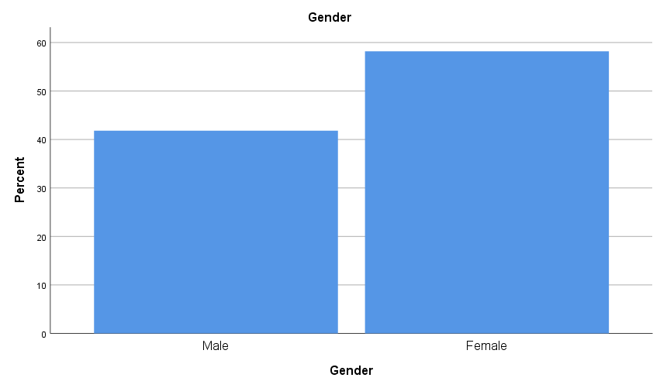

**Education**

|  |  |  |  |
| --- | --- | --- | --- |
|  | | Frequency | Percent |
| Valid | Graduation | 33 | 30.0 |
| Post-Graduation | 57 | 51.8 |
| Phd | 20 | 18.2 |
| Total | 110 | 100.0 |

The study "Synergizing Emotional Intelligence and Transformational Leadership" showcases a rich educational diversity among its 110 participants, enhancing the depth and relevance of its findings. Over half of the participants, 51.8% (57 individuals), hold Post-Graduation degrees, indicating a deep engagement with advanced academic concepts in emotional intelligence and leadership. Graduates, forming 30% (33 individuals) of the sample, signify a strong foundational interest. Notably, Ph.D. holders, making up 18.2% (20 individuals), bring specialized, research-oriented insights to the study. This educational variety contributes to the robustness of the research, amalgamating a wide spectrum of academic perspectives. The significant presence of postgraduates suggests that the study's insights are likely rooted in a blend of theoretical knowledge and practical experience, which is crucial for formulating effective organizational strategies. Thus, the educational background of the participants is key to understanding the interplay between emotional intelligence and transformational leadership in enhancing organizational effectiveness.

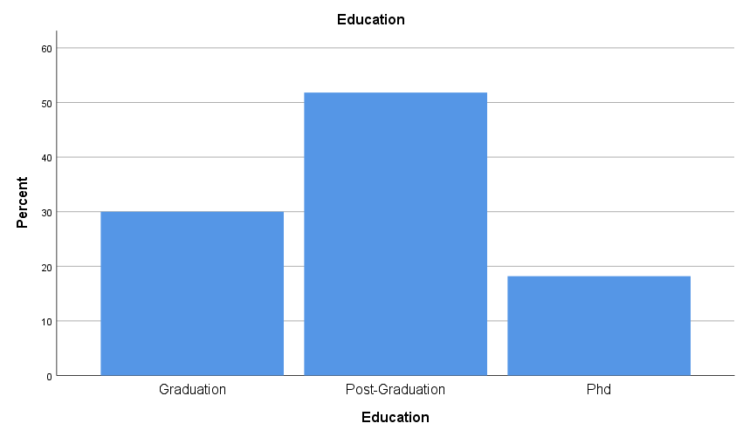

**Experience**

|  |  |  |  |
| --- | --- | --- | --- |
|  | | Frequency | Percent |
| Valid | below 2 year | 12 | 10.9 |
| 2- 5 year | 20 | 18.2 |
| 6-10 year | 28 | 25.5 |
| 11-15 year | 23 | 20.9 |
| 16- 20 year | 18 | 16.4 |
| above 20 year | 9 | 8.2 |
| Total | 110 | 100.0 |

The experience levels of participants vary: 10.9% have less than 2 years, 18.2% have 2-5 years, 25.5% have 6-10 years, 20.9% have 11-15 years, 16.4% have 16-20 years, and 8.2% have over 20 years of experience.

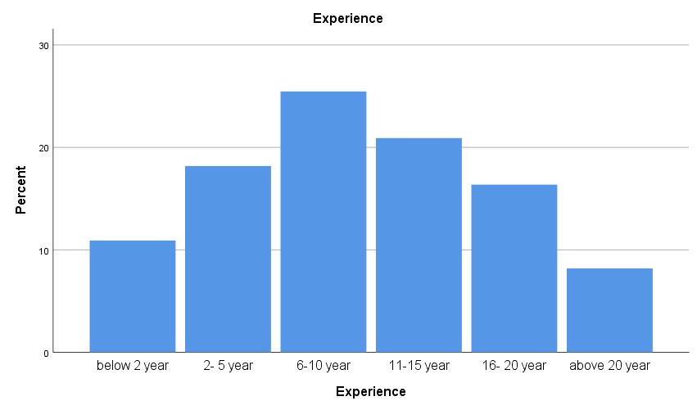

**Nationality**

|  |  |  |  |
| --- | --- | --- | --- |
|  | | Frequency | Percent |
| Valid | India | 76 | 69.1 |
| US | 15 | 13.6 |
| EMEA | 19 | 17.3 |
| Total | 110 | 100.0 |

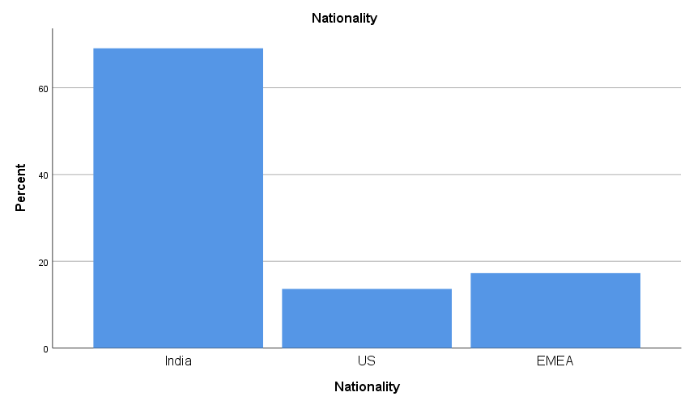

The study "Synergizing Emotional Intelligence and Transformational Leadership" presents a participant demographic primarily composed of individuals from India, accounting for 69.1% (76 participants) of the total 110 participants. This significant representation suggests a strong interest or relevance of the study's themes within the Indian context. Additionally, participants from the US and the EMEA (Europe, Middle East, and Africa) region are also included, with the US contributing 13.6% (15 participants) and EMEA 17.3% (19 participants).

**Level in organization**

|  |  |  |  |
| --- | --- | --- | --- |
|  | | Frequency | Percent |
| Valid | Entry level | 27 | 24.5 |
| Manger level | 30 | 27.3 |
| Senior Manger level | 38 | 34.5 |
| Top Management level | 15 | 13.6 |
| Total | 110 | 100.0 |

In analyzing the hierarchical representation within the study on "Synergizing Emotional Intelligence and Transformational Leadership," the data from 110 participants show a wide spread across different organizational levels. The majority are Senior Managers (34.5%), highlighting the concept's significance at higher managerial echelons. This is closely followed by Manager level individuals (27.3%), indicating its relevance in mid-management. Entry-level participants, making up 24.5%, suggest an emerging interest among those starting their careers. Although Top Management is the least represented group at 13.6%, their insights are crucial for a holistic understanding. The variety in levels underscores the importance of emotional intelligence and transformational leadership across the spectrum of professional development and organizational hierarchy.

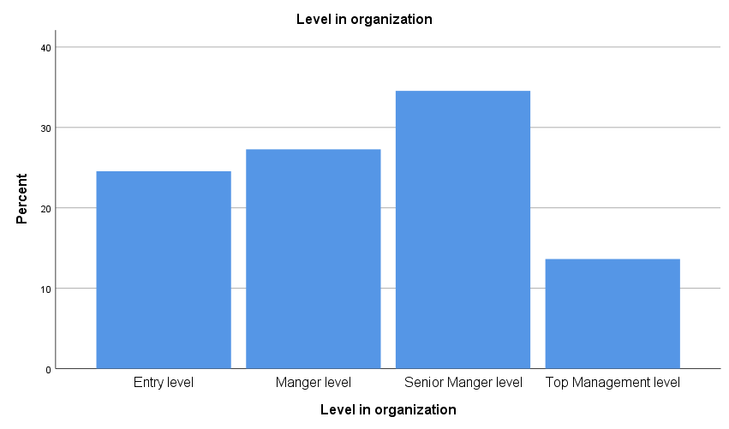

**Gender * How satisfied are you with your ability to recognize your own emotions?**

|  |  |  |  |  |  |  |
| --- | --- | --- | --- | --- | --- | --- |
| Count | | How satisfied are you with your ability to recognize your own emotions? | | | | |
| Strongly Dissatisfied | Dissatisfied | Neutral | Satisfied | Strongly Satisfied |
| Gender | Male | 5 | 2 | 6 | 12 | 21 |
| Female | 6 | 10 | 6 | 17 | 25 |
| Total | | 11 | 12 | 12 | 29 | 46 |

In the survey on recognizing their own emotions, among males, 5 were strongly dissatisfied, 2 dissatisfied, 6 neutral, 12 satisfied, and 21 strongly satisfied. Females showed 6 strongly dissatisfied, 10 dissatisfied, 6 neutral, 17 satisfied, and 25 strongly satisfied. Generally, both genders leaned towards satisfaction, with females displaying a slightly higher dissatisfaction rate.

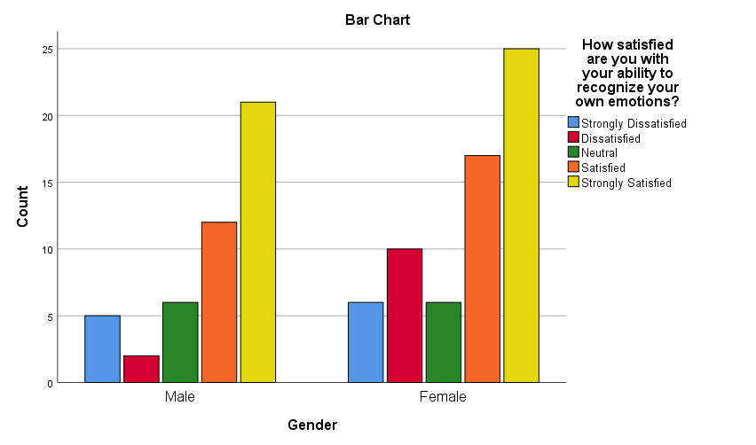

**Gender * How satisfied are you with the frequency at which you consider the emotions of colleagues when making decisions?**

|  |  |  |  |  |  |  |
| --- | --- | --- | --- | --- | --- | --- |
| Count | | How satisfied are you with the frequency at which you consider the emotions of colleagues when making decisions? | | | | |
| Strongly Dissatisfied | Dissatisfied | Neutral | Satisfied | Strongly Satisfied |
| Gender | Male | 2 | 3 | 2 | 18 | 21 |
| Female | 4 | 5 | 6 | 25 | 24 |
| Total | | 6 | 8 | 8 | 43 | 45 |

In assessing satisfaction with considering colleagues' emotions in decision-making: among males, 2 were strongly dissatisfied, 3 dissatisfied, 2 neutral, 18 satisfied, and 21 strongly satisfied. Females reported 4 strongly dissatisfied, 5 dissatisfied, 6 neutral, 25 satisfied, and 24 strongly satisfied. Both genders showed a tendency towards satisfaction, with females slightly more dissatisfied but also more satisfied in their responses.

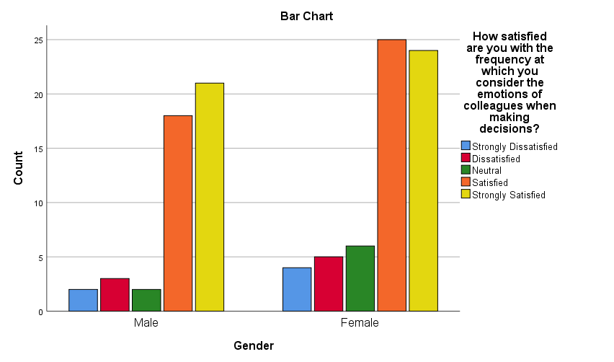

**Gender * How satisfied are you with your ability to manage stress in the workplace?**

|  |  |  |  |  |  |  |
| --- | --- | --- | --- | --- | --- | --- |
| Count | | How satisfied are you with your ability to manage stress in the workplace? | | | | |
| Strongly Dissatisfied | Dissatisfied | Neutral | Satisfied | Strongly Satisfied |
| Gender | Male | 2 | 8 | 3 | 20 | 13 |
| Female | 5 | 5 | 5 | 25 | 24 |
| Total | | 7 | 13 | 8 | 45 | 37 |

In evaluating satisfaction with managing workplace stress: among males, 2 were strongly dissatisfied, 8 dissatisfied, 3 neutral, 20 satisfied, and 13 strongly satisfied. For females, 5 were strongly dissatisfied, 5 dissatisfied, 5 neutral, 25 satisfied, and 24 strongly satisfied. Both genders predominantly leaned towards satisfaction, with females showing a higher level of both strong dissatisfaction and strong satisfaction.

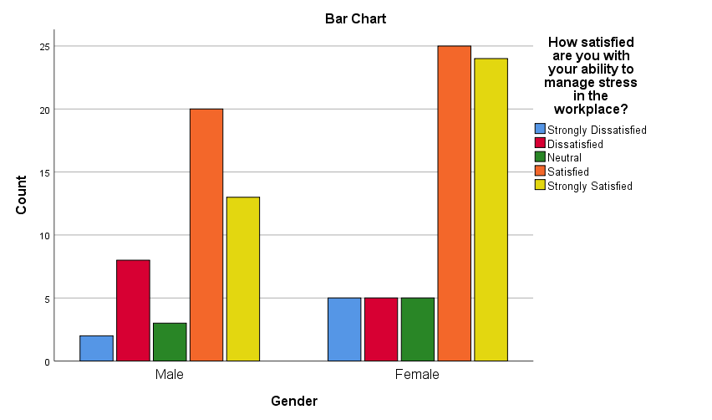

**Gender * How satisfied are you that leaders with high Emotional Intelligence are more effective?**

|  |  |  |  |  |  |  |
| --- | --- | --- | --- | --- | --- | --- |
| Count | | How satisfied are you that leaders with high Emotional Intelligence are more effective? | | | | |
| Strongly Dissatisfied | Dissatisfied | Neutral | Satisfied | Strongly Satisfied |
| Gender | Male | 3 | 6 | 5 | 14 | 18 |
| Female | 7 | 8 | 4 | 27 | 18 |
| Total | | 10 | 14 | 9 | 41 | 36 |

In gauging satisfaction with the effectiveness of leaders with high Emotional Intelligence: among males, 3 were strongly dissatisfied, 6 dissatisfied, 5 neutral, 14 satisfied, and 18 strongly satisfied. Females indicated 7 strongly dissatisfied, 8 dissatisfied, 4 neutral, 27 satisfied, and 18 strongly satisfied. While both genders generally agreed on strong satisfaction, females exhibited a higher level of dissatisfaction.

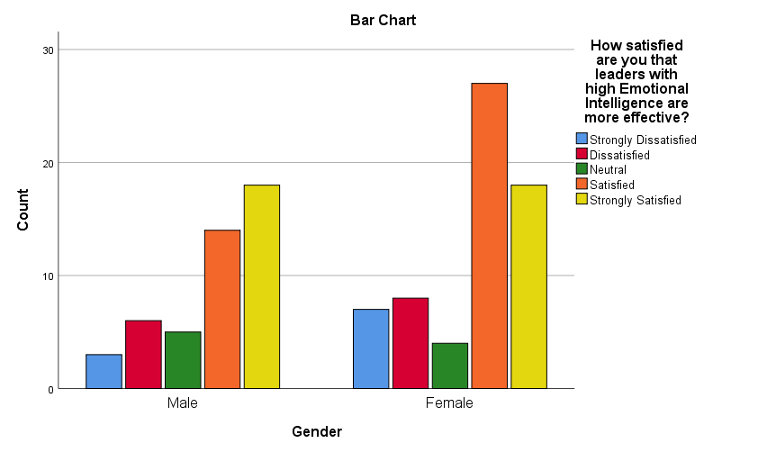

**Gender * How satisfied are you with the frequency at which your leader/manager demonstrates empathy towards team members?**

|  |  |  |  |  |  |  |
| --- | --- | --- | --- | --- | --- | --- |
| Count | | How satisfied are you with the frequency at which your leader/manager demonstrates empathy towards team members? | | | | |
| Strongly Dissatisfied | Dissatisfied | Neutral | Satisfied | Strongly Satisfied |
| Gender | Male | 1 | 5 | 9 | 14 | 17 |
| Female | 4 | 4 | 14 | 20 | 22 |
| Total | | 5 | 9 | 23 | 34 | 39 |

In evaluating satisfaction with leaders'/managers' empathy towards team members: among males, 1 was strongly dissatisfied, 5 dissatisfied, 9 neutral, 14 satisfied, and 17 strongly satisfied. Females reported 4 strongly dissatisfied, 4 dissatisfied, 14 neutral, 20 satisfied, and 22 strongly satisfied. While satisfaction levels are high in both genders, females showed a slightly higher tendency towards both dissatisfaction and strong satisfaction.

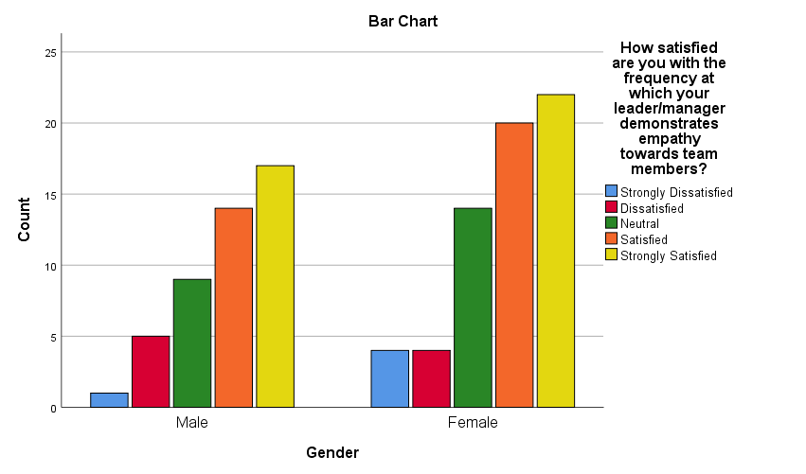

**Gender * How satisfied are you that your leader often uses emotions to enhance the team's overall thinking and decision-making?**

|  |  |  |  |  |  |  |
| --- | --- | --- | --- | --- | --- | --- |
| Count | | How satisfied are you that your leader often uses emotions to enhance the team's overall thinking and decision-making? | | | | |
| Strongly Dissatisfied | Dissatisfied | Neutral | Satisfied | Strongly Satisfied |
| Gender | Male | 1 | 8 | 4 | 19 | 14 |
| Female | 8 | 6 | 3 | 26 | 21 |
| Total | | 9 | 14 | 7 | 45 | 35 |

In assessing satisfaction with leaders using emotions to enhance team thinking and decision-making: among males, 1 was strongly dissatisfied, 8 dissatisfied, 4 neutral, 19 satisfied, and 14 strongly satisfied. Females showed 8 strongly dissatisfied, 6 dissatisfied, 3 neutral, 26 satisfied, and 21 strongly satisfied. Notably, females expressed higher levels of both strong dissatisfaction and strong satisfaction compared to males.

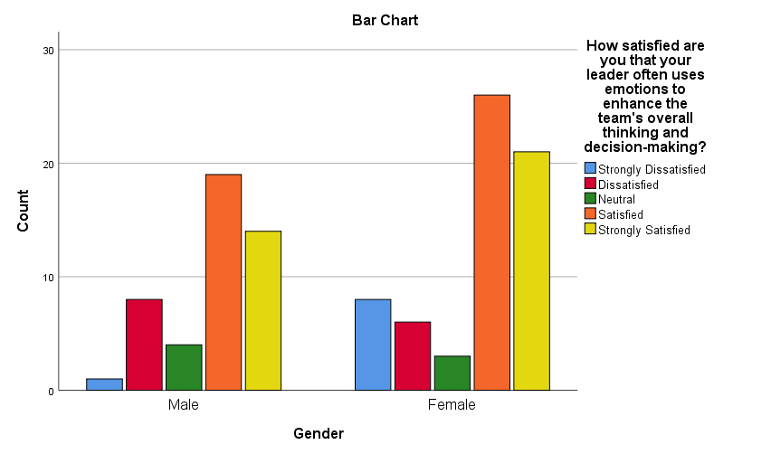

**Gender * How satisfied are you that a leader's ability to relate emotionally increases trust within the team?**

|  |  |  |  |  |  |  |
| --- | --- | --- | --- | --- | --- | --- |
| Count | | How satisfied are you that a leader's ability to relate emotionally increases trust within the team? | | | | |
| Strongly Dissatisfied | Dissatisfied | Neutral | Satisfied | Strongly Satisfied |
| Gender | Male | 2 | 6 | 3 | 18 | 17 |
| Female | 2 | 10 | 9 | 19 | 24 |
| Total | | 4 | 16 | 12 | 37 | 41 |

In the survey about satisfaction with the idea that a leader's emotional relatability increases team trust: among males, 2 were strongly dissatisfied, 6 dissatisfied, 3 neutral, 18 satisfied, and 17 strongly satisfied. Females reported 2 strongly dissatisfied, 10 dissatisfied, 9 neutral, 19 satisfied, and 24 strongly satisfied. Both genders leaned towards satisfaction, with females showing a higher level of dissatisfaction but also a greater inclination towards strong satisfaction.

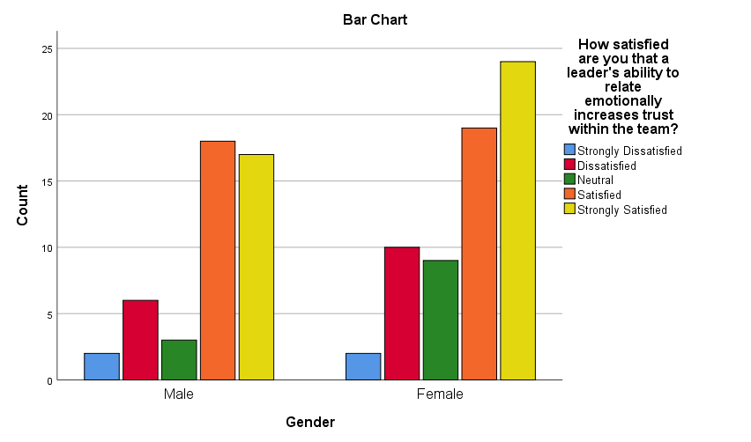

**Gender * How satisfied are you with your leader's capability to harness team emotions positively?**

|  |  |  |  |  |  |  |
| --- | --- | --- | --- | --- | --- | --- |
| Count | | How satisfied are you with your leader's capability to harness team emotions positively? | | | | |
| Strongly Dissatisfied | Dissatisfied | Neutral | Satisfied | Strongly Satisfied |
| Gender | Male | 0 | 4 | 8 | 23 | 11 |
| Female | 5 | 9 | 5 | 26 | 19 |
| Total | | 5 | 13 | 13 | 49 | 30 |

The data on leaders' ability to harness team emotions positively shows varied satisfaction levels across genders. Among males, 11 feel strongly satisfied and 23 satisfied with their leader's capability in this regard. Females, however, exhibit a broader range of responses: 19 are strongly satisfied and 26 are satisfied, but there's also a notable presence of dissatisfaction, with 5 strongly dissatisfied and 9 dissatisfied. This disparity indicates that while the positive management of team emotions is recognized as important by both genders, the effectiveness of such leadership skills is perceived differently, suggesting a need for tailored emotional intelligence development in leadership roles.

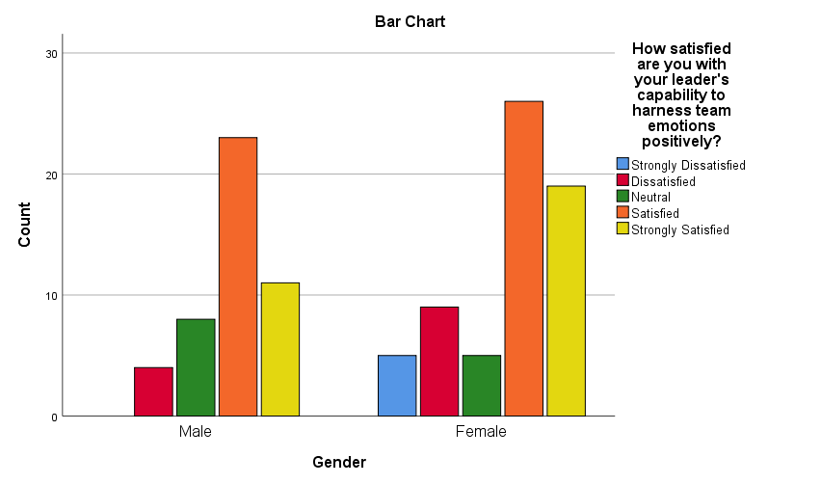

**Gender * How satisfied are you with the importance of a leader's self-awareness in influencing team performance?**

|  |  |  |  |  |  |  |
| --- | --- | --- | --- | --- | --- | --- |
| Count | | How satisfied are you with the importance of a leader's self-awareness in influencing team performance? | | | | |
| Strongly Dissatisfied | Dissatisfied | Neutral | Satisfied | Strongly Satisfied |
| Gender | Male | 3 | 4 | 8 | 16 | 15 |
| Female | 7 | 12 | 5 | 19 | 21 |
| Total | | 10 | 16 | 13 | 35 | 36 |

The survey regarding a leader's self-awareness and its impact on team performance reveals a clear gender divergence in perspectives. Males generally acknowledge its importance, with 15 expressing strong satisfaction and 16 being satisfied. However, females show a greater appreciation, with 21 strongly satisfied and 19 satisfied, but also a higher level of dissatisfaction, with 7 strongly dissatisfied and 12 dissatisfied. This indicates that while both genders recognize the significance of self-awareness in leadership, females may have higher expectations or different experiences regarding its influence on team dynamics, underscoring the need for focused development in this area of leadership.

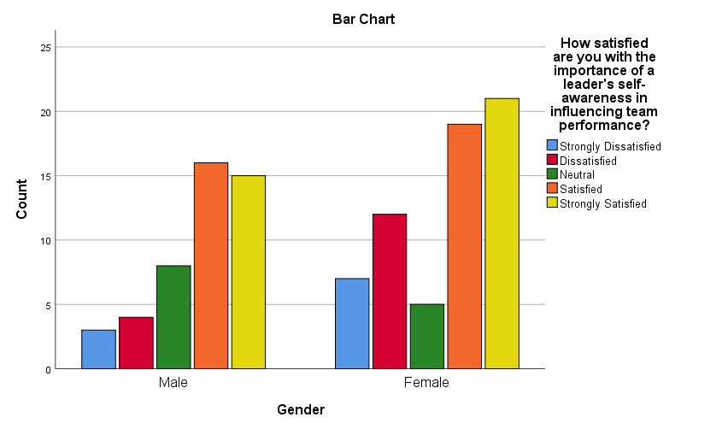

**Gender * How satisfied are you with the importance of a leader's self-awareness in influencing team performance?**

|  |  |  |  |  |  |  |
| --- | --- | --- | --- | --- | --- | --- |
| Count | | How satisfied are you with the importance of a leader's self-awareness in influencing team performance? | | | | |
| Strongly Dissatisfied | Dissatisfied | Neutral | Satisfied | Strongly Satisfied |
| Gender | Male | 3 | 4 | 8 | 16 | 15 |
| Female | 7 | 12 | 5 | 19 | 21 |
| Total | | 10 | 16 | 13 | 35 | 36 |

In the context of a leader's self-awareness and its impact on team performance, the data highlights distinct perceptions based on gender. For males, 15 are strongly satisfied and 16 are satisfied with the role of a leader's self-awareness in influencing team dynamics. Conversely, females demonstrate a higher regard, with 21 strongly satisfied and 19 satisfied, but they also exhibit a considerable amount of dissatisfaction, with 7 strongly dissatisfied and 12 dissatisfied. This pattern indicates a general acknowledgment of the importance of self-awareness in leadership across genders, yet it also reveals differing degrees of satisfaction with its actual influence on team performance, pointing to the potential for more targeted leadership training in this area.



**Gender * How interested are you in attending a workshop or training focused on enhancing Emotional Intelligence for leadership roles?**

|  |  |  |  |  |  |  |
| --- | --- | --- | --- | --- | --- | --- |
| Count | | How interested are you in attending a workshop or training focused on enhancing Emotional Intelligence for leadership roles? | | | | |
| Strongly Dissatisfied | Dissatisfied | Neutral | Satisfied | Strongly Satisfied |
| Gender | Male | 2 | 2 | 5 | 20 | 17 |
| Female | 2 | 8 | 4 | 23 | 27 |
| Total | | 4 | 10 | 9 | 43 | 44 |

In gauging interest in attending a workshop or training for enhancing Emotional Intelligence in leadership roles: among males, 2 were strongly dissatisfied, 2 dissatisfied, 5 neutral, 20 satisfied, and 17 strongly satisfied. Females indicated 2 strongly dissatisfied, 8 dissatisfied, 4 neutral, 23 satisfied, and 27 strongly satisfied. Overall, both genders showed a high level of interest, with females displaying slightly more dissatisfaction but also a greater number of strongly satisfied responses.

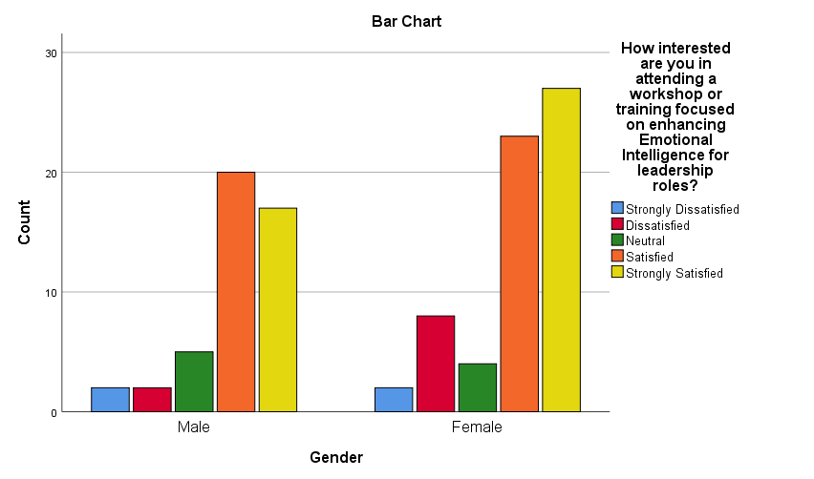

Education * How satisfied are you with your ability to recognize your own emotions?

|  |  |  |  |  |  |  |
| --- | --- | --- | --- | --- | --- | --- |
| Count | | How satisfied are you with your ability to recognize your own emotions? | | | | |
| Strongly Dissatisfied | Dissatisfied | Neutral | Satisfied | Strongly Satisfied |
| Education | Graduation | 5 | 4 | 2 | 9 | 13 |
| Post-Graduation | 3 | 8 | 6 | 17 | 23 |
| Phd | 3 | 0 | 4 | 3 | 10 |
| Total | | 11 | 12 | 12 | 29 | 46 |

In evaluating satisfaction with the ability to recognize their own emotions based on educational background: Graduates reported 5 strongly dissatisfied, 4 dissatisfied, 2 neutral, 9 satisfied, and 13 strongly satisfied. Post-Graduates showed 3 strongly dissatisfied, 8 dissatisfied, 6 neutral, 17 satisfied, and 23 strongly satisfied. Ph.D. holders had 3 strongly dissatisfied, none dissatisfied, 4 neutral, 3 satisfied, and 10 strongly satisfied. The tendency towards satisfaction was evident across all education levels, with Post-Graduates showing the highest satisfaction levels.

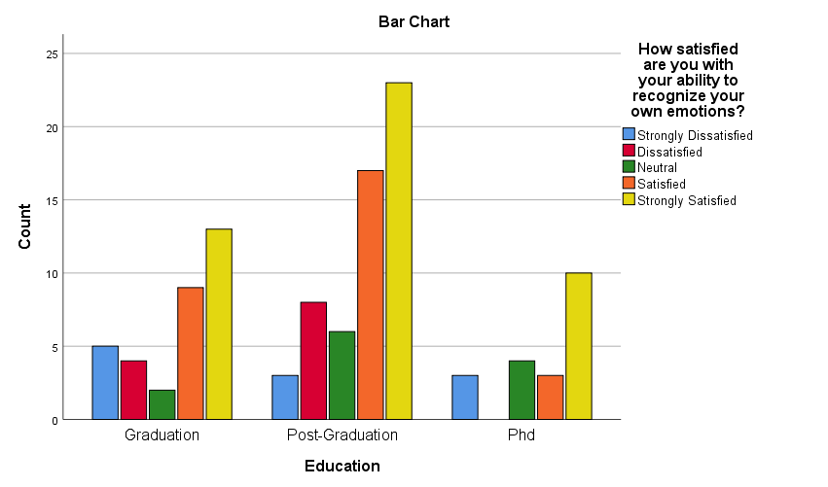

Education * How satisfied are you with the frequency at which you consider the emotions of colleagues when making decisions?

|  |  |  |  |  |  |  |
| --- | --- | --- | --- | --- | --- | --- |
| Count | | How satisfied are you with the frequency at which you consider the emotions of colleagues when making decisions? | | | | |
| Strongly Dissatisfied | Dissatisfied | Neutral | Satisfied | Strongly Satisfied |
| Education | Graduation | 2 | 3 | 2 | 13 | 13 |
| Post-Graduation | 3 | 3 | 5 | 22 | 24 |
| Phd | 1 | 2 | 1 | 8 | 8 |
| Total | | 6 | 8 | 8 | 43 | 45 |

Regarding satisfaction with the frequency of considering colleagues' emotions in decision-making, based on education levels: Graduates showed 2 strongly dissatisfied, 3 dissatisfied, 2 neutral, 13 satisfied, and 13 strongly satisfied. Post-Graduates had 3 strongly dissatisfied, 3 dissatisfied, 5 neutral, 22 satisfied, and 24 strongly satisfied. Ph.D. holders reported 1 strongly dissatisfied, 2 dissatisfied, 1 neutral, 8 satisfied, and 8 strongly satisfied. Across all education levels, there's a notable lean towards satisfaction, with Post-Graduates demonstrating the highest levels of satisfaction and strong satisfaction.

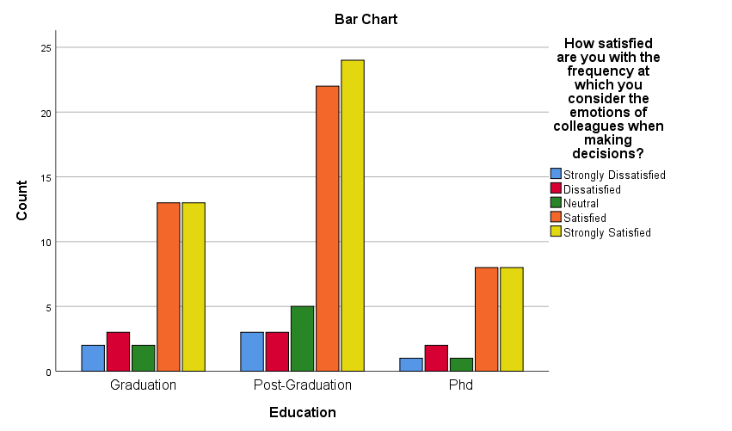

Education * How satisfied are you with your ability to manage stress in the workplace?

|  |  |  |  |  |  |  |
| --- | --- | --- | --- | --- | --- | --- |
| Count | | How satisfied are you with your ability to manage stress in the workplace? | | | | |
| Strongly Dissatisfied | Dissatisfied | Neutral | Satisfied | Strongly Satisfied |
| Education | Graduation | 1 | 2 | 1 | 16 | 13 |
| Post-Graduation | 5 | 7 | 5 | 19 | 21 |
| Phd | 1 | 4 | 2 | 10 | 3 |
| Total | | 7 | 13 | 8 | 45 | 37 |

Regarding satisfaction with managing workplace stress across educational levels: Graduates showed 1 strongly dissatisfied, 2 dissatisfied, 1 neutral, 16 satisfied, and 13 strongly satisfied. Post-Graduates had 5 strongly dissatisfied, 7 dissatisfied, 5 neutral, 19 satisfied, and 21 strongly satisfied. Ph.D. holders reported 1 strongly dissatisfied, 4 dissatisfied, 2 neutral, 10 satisfied, and 3 strongly satisfied. Overall, while satisfaction is prevalent across all groups, Post-Graduates have a higher proportion of both strong dissatisfaction and strong satisfaction compared to Graduates and Ph.D. holders.

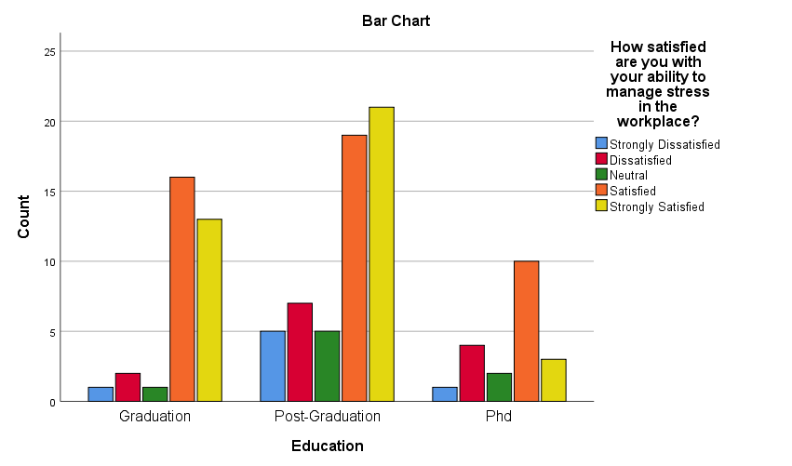

Education * How satisfied are you that leaders with high Emotional Intelligence are more effective?

|  |  |  |  |  |  |  |
| --- | --- | --- | --- | --- | --- | --- |
| Count | | How satisfied are you that leaders with high Emotional Intelligence are more effective? | | | | |
| Strongly Dissatisfied | Dissatisfied | Neutral | Satisfied | Strongly Satisfied |
| Education | Graduation | 1 | 6 | 2 | 15 | 9 |
| Post-Graduation | 8 | 6 | 5 | 19 | 19 |
| Phd | 1 | 2 | 2 | 7 | 8 |
| Total | | 10 | 14 | 9 | 41 | 36 |

In assessing satisfaction with the effectiveness of leaders with high Emotional Intelligence, based on education levels: Graduates indicated 1 strongly dissatisfied, 6 dissatisfied, 2 neutral, 15 satisfied, and 9 strongly satisfied. Post-Graduates showed 8 strongly dissatisfied, 6 dissatisfied, 5 neutral, 19 satisfied, and 19 strongly satisfied. Ph.D. holders had 1 strongly dissatisfied, 2 dissatisfied, 2 neutral, 7 satisfied, and 8 strongly satisfied. While satisfaction is a common trend, Post-Graduates displayed a higher level of both strong dissatisfaction and strong satisfaction compared to Graduates and Ph.D. holders.

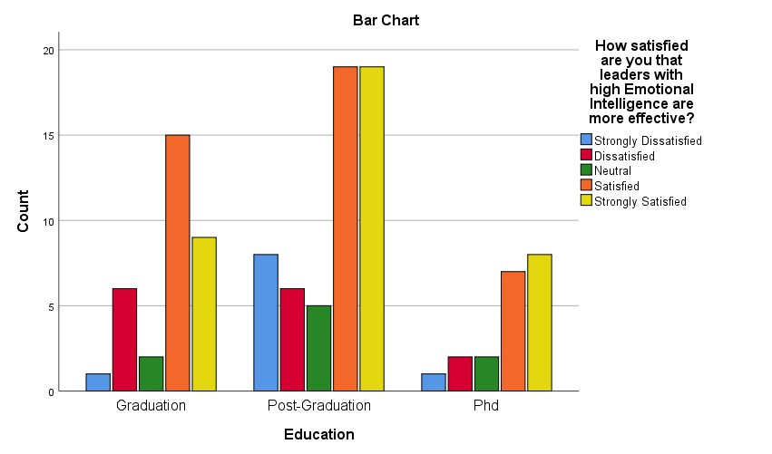

Education * How satisfied are you that your leader often uses emotions to enhance the team's overall thinking and decision-making?

|  |  |  |  |  |  |  |
| --- | --- | --- | --- | --- | --- | --- |
| Count | | How satisfied are you that your leader often uses emotions to enhance the team's overall thinking and decision-making? | | | | |
| Strongly Dissatisfied | Dissatisfied | Neutral | Satisfied | Strongly Satisfied |
| Education | Graduation | 6 | 2 | 1 | 16 | 8 |
| Post-Graduation | 2 | 6 | 5 | 24 | 20 |
| Phd | 1 | 6 | 1 | 5 | 7 |
| Total | | 9 | 14 | 7 | 45 | 35 |

In the survey assessing satisfaction with how leaders use emotions to enhance team thinking and decision-making across different educational levels, the responses varied. Graduates expressed a mixed response with 6 strongly dissatisfied and 2 dissatisfied, but there was a tilt towards satisfaction, with 16 satisfied and 8 strongly satisfied. Post-Graduates, however, showed a more positive outlook, with only 2 strongly dissatisfied and 6 dissatisfied, contrasted by a significant number of 24 satisfied and 20 strongly satisfied. This suggests a higher appreciation for emotional intelligence in leadership among those with higher educational attainment. On the other hand, Ph.D. holders displayed a balanced view, with 1 strongly dissatisfied, 6 dissatisfied, 1 neutral, 5 satisfied, and 7 strongly satisfied. This indicates a cautious perspective on the role of emotions in leadership decision-making at the highest level of academic qualification.

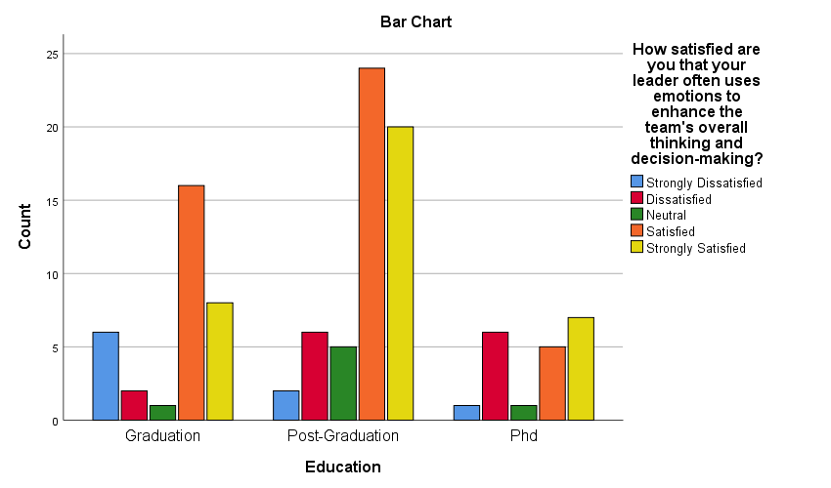

Education * How satisfied are you that a leader's ability to relate emotionally increases trust within the team?

|  |  |  |  |  |  |  |
| --- | --- | --- | --- | --- | --- | --- |
| Count | | How satisfied are you that a leader's ability to relate emotionally increases trust within the team? | | | | |
| Strongly Dissatisfied | Dissatisfied | Neutral | Satisfied | Strongly Satisfied |
| Education | Graduation | 1 | 4 | 3 | 14 | 11 |
| Post-Graduation | 2 | 9 | 5 | 18 | 23 |
| Phd | 1 | 3 | 4 | 5 | 7 |
| Total | | 4 | 16 | 12 | 37 | 41 |

In assessing satisfaction with the effectiveness of leaders with high Emotional Intelligence, based on education levels: Graduates indicated 1 strongly dissatisfied, 4 dissatisfied, 3 neutral, 14 satisfied, and 11 strongly satisfied. Post-Graduates showed 2 strongly dissatisfied, 9 dissatisfied, 5 neutral, 18 satisfied, and 23 strongly satisfied. Ph.D. holders had 1 strongly dissatisfied, 3 dissatisfied, 4 neutral, 5 satisfied, and 7 strongly satisfied. Notably, while a trend of satisfaction is evident across all levels, Post-Graduates displayed a higher level of both satisfaction and strong satisfaction, highlighting a more pronounced belief in the impact of emotional intelligence on trust within teams, compared to Graduates and Ph.D. holders.

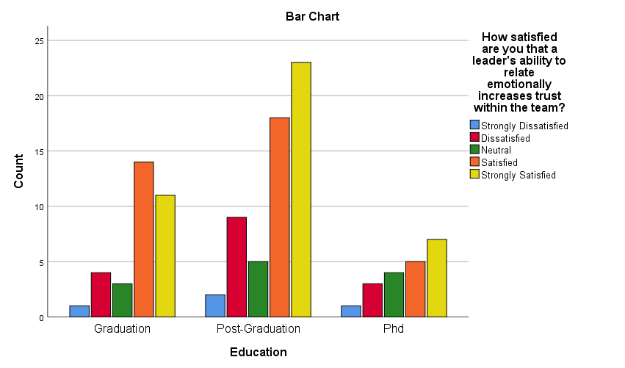

Education * How satisfied are you with your leader's capability to harness team emotions positively?

|  |  |  |  |  |  |  |
| --- | --- | --- | --- | --- | --- | --- |
| Count | | How satisfied are you with your leader's capability to harness team emotions positively? | | | | |
| Strongly Dissatisfied | Dissatisfied | Neutral | Satisfied | Strongly Satisfied |
| Education | Graduation | 1 | 5 | 3 | 13 | 11 |
| Post-Graduation | 2 | 6 | 10 | 26 | 13 |
| Phd | 2 | 2 | 0 | 10 | 6 |
| Total | | 5 | 13 | 13 | 49 | 30 |

In evaluating satisfaction with leaders' ability to positively harness team emotions, based on education levels: Graduates expressed 1 strongly dissatisfied, 5 dissatisfied, 3 neutral, 13 satisfied, and 11 strongly satisfied. Post-Graduates indicated 2 strongly dissatisfied, 6 dissatisfied, 10 neutral, 26 satisfied, and 13 strongly satisfied. Ph.D. holders reported 2 strongly dissatisfied, 2 dissatisfied, 0 neutral, 10 satisfied, and 6 strongly satisfied. This data suggests a general positivity across all educational levels towards leaders' emotional management skills. Notably, Post-Graduates, despite having a higher number of neutral responses, also show the highest satisfaction, indicating a nuanced perspective on the importance and effectiveness of emotional intelligence in leadership among those with advanced education.

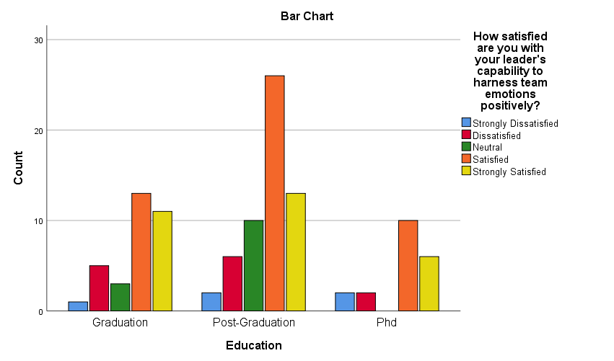

Education * How satisfied are you with your leader's capability to harness team emotions positively?

|  |  |  |  |  |  |  |
| --- | --- | --- | --- | --- | --- | --- |
| Count | | How satisfied are you with your leader's capability to harness team emotions positively? | | | | |
| Strongly Dissatisfied | Dissatisfied | Neutral | Satisfied | Strongly Satisfied |
| Education | Graduation | 4 | 6 | 3 | 9 | 11 |
| Post-Graduation | 4 | 9 | 7 | 22 | 15 |
| Phd | 2 | 1 | 3 | 4 | 10 |
| Total | | 10 | 16 | 13 | 35 | 36 |

In reviewing satisfaction with leaders' ability to positively harness team emotions, based on education levels: Graduates reported 4 strongly dissatisfied, 6 dissatisfied, 3 neutral, 9 satisfied, and 11 strongly satisfied. Post-Graduates indicated 4 strongly dissatisfied, 9 dissatisfied, 7 neutral, 22 satisfied, and 15 strongly satisfied. Ph.D. holders expressed 2 strongly dissatisfied, 1 dissatisfied, 3 neutral, 4 satisfied, and 10 strongly satisfied. This data reveals a mixed response across educational groups, with a notable trend towards satisfaction in each group. Graduates and Post-Graduates show a higher level of dissatisfaction compared to Ph.D. holders, who, despite their small numbers, exhibit a significant lean towards strong satisfaction.

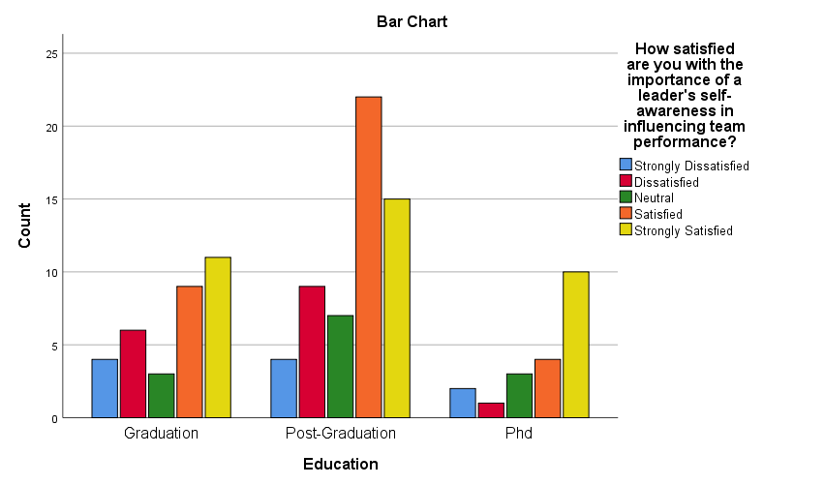

Education * How interested are you in attending a workshop or training focused on enhancing Emotional Intelligence for leadership roles?

|  |  |  |  |  |  |  |
| --- | --- | --- | --- | --- | --- | --- |
| Count | | How satisfied are you that leaders with high Emotional Intelligence are more effective? | | | | |
| Strongly Dissatisfied | Dissatisfied | Neutral | Satisfied | Strongly Satisfied |
| Education | Graduation | 1 | 4 | 2 | 14 | 12 |
| Post-Graduation | 2 | 5 | 6 | 23 | 21 |
| Phd | 1 | 1 | 1 | 6 | 11 |
| Total | | 4 | 10 | 9 | 43 | 44 |

Analyzing interest in attending workshops or training to enhance Emotional Intelligence (EI) for leadership roles, based on education levels: Graduates showed 1 strongly dissatisfied, 4 dissatisfied, 2 neutral, 14 satisfied, and 12 strongly satisfied. Post-Graduates indicated 2 strongly dissatisfied, 5 dissatisfied, 6 neutral, 23 satisfied, and 21 strongly satisfied. Ph.D. holders expressed 1 strongly dissatisfied, 1 dissatisfied, 1 neutral, 6 satisfied, and 11 strongly satisfied. The data reveals a clear inclination towards such training across all educational levels, with a notable skew towards high satisfaction. Post-Graduates, in particular, exhibit a strong interest in EI-focused training, evident in their high satisfaction numbers.

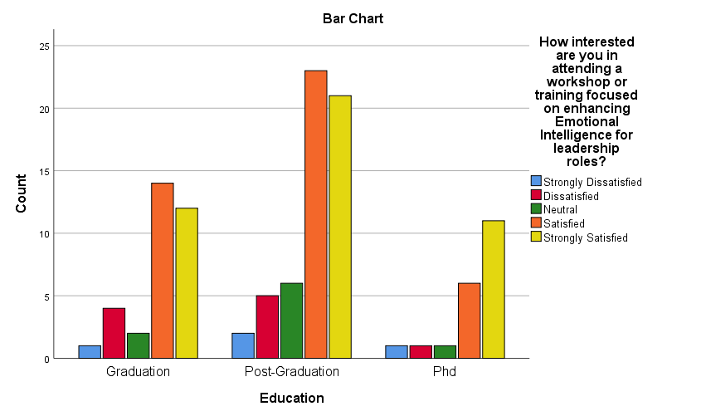

Education * How satisfied are you that leaders with high Emotional Intelligence are more adaptable to organizational changes?

|  |  |  |  |  |  |  |
| --- | --- | --- | --- | --- | --- | --- |
| Count | | How satisfied are you that leaders with high Emotional Intelligence are more effective? | | | | |
| Strongly Dissatisfied | Dissatisfied | Neutral | Satisfied | Strongly Satisfied |
| Education | Graduation | 0 | 2 | 0 | 16 | 15 |
| Post-Graduation | 2 | 7 | 9 | 26 | 13 |
| Phd | 1 | 5 | 0 | 4 | 10 |
| Total | | 3 | 14 | 9 | 46 | 38 |

The data on the perceived adaptability of leaders with high Emotional Intelligence (EI) to organizational changes indicates a clear trend across educational levels. Graduates show a strong belief in this adaptability, with a majority (16) feeling satisfied. Post-graduates also lean towards a positive view, with the highest count (26) being satisfied, despite a noticeable number (9) remaining neutral. Ph.D. holders, conversely, exhibit a more divided stance, with only a small group (4) feeling satisfied, highlighting a potentially more critical or varied perspective on EI and adaptability at this advanced educational level.

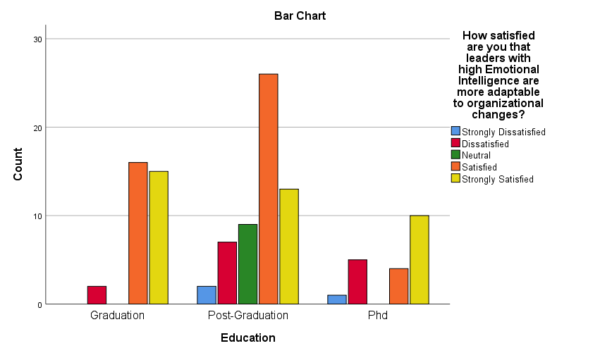

**Experience * How satisfied are you with your ability to recognize your own emotions?**

|  |  |  |  |  |  |  |
| --- | --- | --- | --- | --- | --- | --- |
| Count | | How satisfied are you with your ability to recognize your own emotions? | | | | |
| Strongly Dissatisfied | Dissatisfied | Neutral | Satisfied | Strongly Satisfied |
| Experience | below 2 year | 2 | 3 | 0 | 4 | 3 |
| 2- 5 year | 2 | 1 | 1 | 7 | 9 |
| 6-10 year | 0 | 5 | 3 | 9 | 11 |
| 11-15 year | 6 | 2 | 2 | 4 | 9 |
| 16- 20 year | 0 | 1 | 2 | 2 | 13 |
| above 20 year | 1 | 0 | 4 | 3 | 1 |
| Total | | 11 | 12 | 12 | 29 | 46 |

In examining the questionnaire results regarding the ability to recognize one's own emotions, it is evident that satisfaction levels vary across different experience brackets. For those with less than 2 years of experience, there are no neutral responses, with 4 satisfied and 3 strongly satisfied individuals. Professionals with 2-5 years of experience show a slight inclination towards higher emotional recognition satisfaction, with 1 neutral, 7 satisfied, and 9 strongly satisfied responses. In the 6-10 years experience group, the trend of increasing satisfaction continues with 3 neutral, 9 satisfied, and 11 strongly satisfied responses. This suggests a growth in emotional intelligence as professional experience accumulates, highlighting the potential impact of experience on emotional self-awareness, a key component in developing transformational leadership skills.

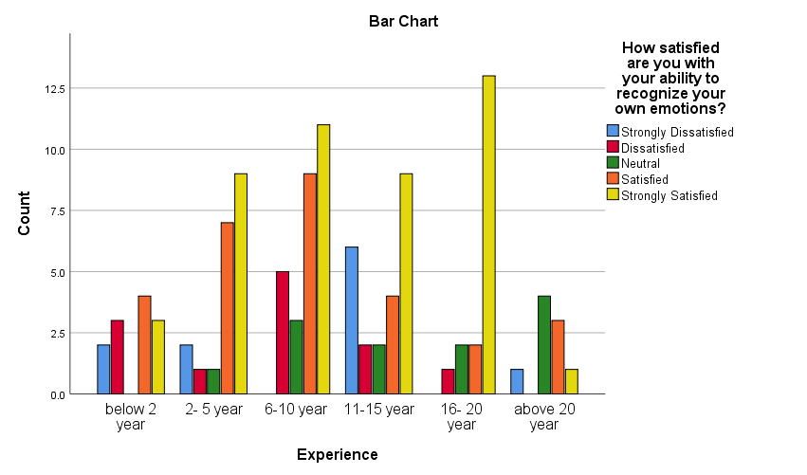

Experience * How satisfied are you with the frequency at which you consider the emotions of colleagues when making decisions?

|  |  |  |  |  |  |  |
| --- | --- | --- | --- | --- | --- | --- |
| Count | | How satisfied are you with the frequency at which you consider the emotions of colleagues when making decisions? | | | | |
| Strongly Dissatisfied | Dissatisfied | Neutral | Satisfied | Strongly Satisfied |
| Experience | below 2 year | 1 | 2 | 0 | 5 | 4 |
| 2- 5 year | 1 | 1 | 3 | 6 | 9 |
| 6-10 year | 3 | 0 | 1 | 12 | 12 |
| 11-15 year | 0 | 4 | 1 | 8 | 10 |
| 16- 20 year | 1 | 0 | 2 | 8 | 7 |
| above 20 year | 0 | 1 | 1 | 4 | 3 |
| Total | | 6 | 8 | 8 | 43 | 45 |

The survey data on satisfaction with the frequency of considering colleagues' emotions in decision-making reveals interesting patterns across varying levels of experience. Among those with less than 2 years of experience, there's a balanced view with 5 satisfied and 4 strongly satisfied, suggesting an early awareness of the importance of emotional considerations in decisions. The 2-5 year experience group shows a positive trend, with 6 satisfied and 9 strongly satisfied, indicating a growing recognition of emotional factors in decision-making as experience increases. This trend is further emphasized in the 6-10 year bracket, where high satisfaction is evident (12 satisfied and 12 strongly satisfied), reflecting a strong emphasis on emotional intelligence at this career stage. Professionals with 11-15 and 16-20 years of experience also show a leaning towards satisfaction (18 and 15 in the satisfied and strongly satisfied categories, respectively), indicating a consistent appreciation for emotional factors in decisions. Interestingly, those with over 20 years of experience present a more varied response, with 4 satisfied and 3 strongly satisfied, possibly suggesting a shift in decision-making approaches with extensive experience. These results underscore the progressive integration and value of emotional intelligence in workplace decision-making across different career stages.

**Experience * How satisfied are you with your ability to manage stress in the workplace?**

|  |  |  |  |  |  |  |
| --- | --- | --- | --- | --- | --- | --- |
| Count | | How satisfied are you with your ability to manage stress in the workplace? | | | | |
| Strongly Dissatisfied | Dissatisfied | Neutral | Satisfied | Strongly Satisfied |
| Experience | below 2 year | 1 | 2 | 2 | 2 | 5 |
| 2- 5 year | 1 | 1 | 0 | 13 | 5 |
| 6-10 year | 4 | 2 | 2 | 9 | 11 |
| 11-15 year | 0 | 4 | 2 | 6 | 11 |
| 16- 20 year | 1 | 3 | 1 | 9 | 4 |
| above 20 year | 0 | 1 | 1 | 6 | 1 |
| Total | | 7 | 13 | 8 | 45 | 37 |

For the question on satisfaction with the ability to manage stress in the workplace, the responses are as follows: For those with below 2 years of experience, there's a spread across the spectrum with 1 strongly dissatisfied, 2 dissatisfied, 2 neutral, 2 satisfied, and 5 strongly satisfied. The 2-5 year group shows a more positive trend, with 1 strongly dissatisfied, 1 dissatisfied, 13 satisfied, and 5 strongly satisfied. In the 6-10 year experience range, the responses are more mixed, with 4 strongly dissatisfied, 2 dissatisfied, 2 neutral, 9 satisfied, and 11 strongly satisfied. Those with 11-15 years of experience have no strongly dissatisfied responses, but 4 dissatisfied, 2 neutral, 6 satisfied, and 11 strongly satisfied. The 16-20 year group also shows diverse responses with 1 strongly dissatisfied, 3 dissatisfied, 1 neutral, 9 satisfied, and 4 strongly satisfied. Lastly, individuals with over 20 years of experience reported no strongly dissatisfied, 1 dissatisfied, 1 neutral, 6 satisfied, and 1 strongly satisfied.

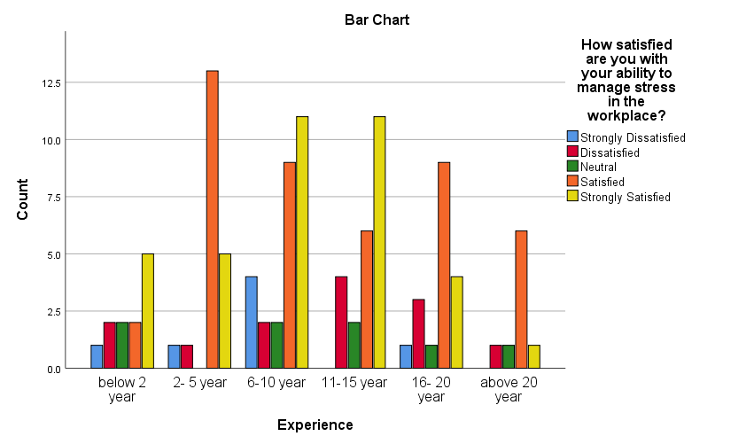

**Experience * How satisfied are you that leaders with high Emotional Intelligence are more effective?**

|  |  |  |  |  |  |  |
| --- | --- | --- | --- | --- | --- | --- |
| Count | | How satisfied are you that leaders with high Emotional Intelligence are more effective? | | | | |
| Strongly Dissatisfied | Dissatisfied | Neutral | Satisfied | Strongly Satisfied |
| Experience | below 2 year | 1 | 1 | 3 | 5 | 2 |
| 2- 5 year | 1 | 3 | 3 | 7 | 6 |
| 6-10 year | 4 | 3 | 0 | 11 | 10 |
| 11-15 year | 3 | 2 | 1 | 8 | 9 |
| 16- 20 year | 1 | 1 | 1 | 9 | 6 |
| above 20 year | 0 | 4 | 1 | 1 | 3 |
| Total | | 10 | 14 | 9 | 41 | 36 |

In response to the question about the effectiveness of leaders with high Emotional Intelligence (EI), the data across different experience levels shows varied perceptions. Those with below 2 years of experience exhibit a balanced view, with 1 strongly dissatisfied, 1 dissatisfied, 3 neutral, 5 satisfied, and 2 strongly satisfied. In the 2-5 year experience group, there's a slight skew towards satisfaction, with 1 strongly dissatisfied, 3 dissatisfied, 3 neutral, 7 satisfied, and 6 strongly satisfied.

Professionals with 6-10 years of experience show a stronger belief in EI's effectiveness in leadership, with 4 strongly dissatisfied, 3 dissatisfied, and a notable majority of 21 respondents either satisfied or strongly satisfied. The 11-15 year bracket also leans towards satisfaction (8 satisfied and 9 strongly satisfied), despite 3 strongly dissatisfied and 2 dissatisfied responses.

For those with 16-20 years of experience, responses are more evenly distributed with 1 in each of the strongly dissatisfied, dissatisfied, and neutral categories, and a combined 15 satisfied or strongly satisfied. Interestingly, individuals with over 20 years of experience present a diverse range of opinions, with 0 strongly dissatisfied, 4 dissatisfied, 1 neutral, 1 satisfied, and 3 strongly satisfied, possibly reflecting a more critical view of EI in leadership with increasing experience. This suggests an evolving perspective on the role of EI in effective leadership across different career stages.

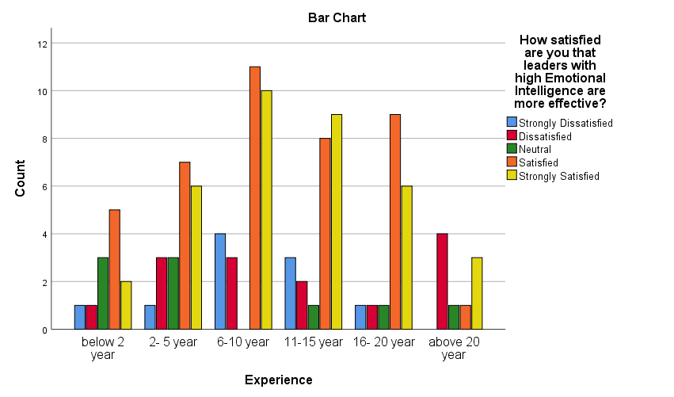

**Level in organization * How satisfied are you with your leader's capability to harness team emotions positively?**

|  |  |  |  |  |  |  |
| --- | --- | --- | --- | --- | --- | --- |
| Count | | How satisfied are you with your leader's capability to harness team emotions positively? | | | | |
| Strongly Dissatisfied | Dissatisfied | Neutral | Satisfied | Strongly Satisfied |
| Level in organization | Entry level | 1 | 4 | 4 | 14 | 4 |
| Manger level | 1 | 3 | 5 | 10 | 11 |
| Senior Manger level | 0 | 6 | 3 | 18 | 11 |
| Top Management level | 3 | 0 | 1 | 7 | 4 |
| Total | | 5 | 13 | 13 | 49 | 30 |

The survey data on satisfaction with leaders' capability to harness team emotions positively varies across different organizational levels. At the entry level, there's a tendency towards satisfaction, with 1 strongly dissatisfied, 4 dissatisfied, 4 neutral, 14 satisfied, and 4 strongly satisfied responses. This suggests a generally positive perception of leadership's emotional intelligence among newer employees. Manager level individuals exhibit a more balanced view, with 1 strongly dissatisfied, 3 dissatisfied, 5 neutral, 10 satisfied, and 11 strongly satisfied responses. This indicates a recognition of leaders' emotional capabilities, yet with some reservations. At the senior manager level, while there are no strongly dissatisfied responses, 6 dissatisfied, 3 neutral, 18 satisfied, and 11 strongly satisfied responses point to a higher satisfaction with leaders' emotional handling, reflecting an appreciation for emotional intelligence at higher career stages. Top management personnel, however, show a diverse perspective, with 3 strongly dissatisfied, no dissatisfied, 1 neutral, 7 satisfied, and 4 strongly satisfied responses. This variation could suggest critical insights into leadership's emotional management from those at the highest organizational tiers. The overall data reflects a nuanced view of leaders' emotional intelligence across organizational levels, highlighting areas for potential improvement in leadership training and development.

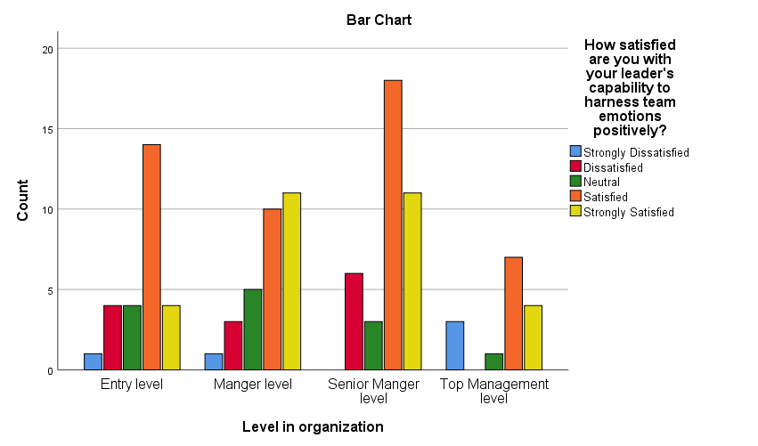

**Level in organization * How satisfied are you with the importance of a leader's self-awareness in influencing team performance?**

|  |  |  |  |  |  |  |
| --- | --- | --- | --- | --- | --- | --- |
| Count | | How satisfied are you with the importance of a leader's self-awareness in influencing team performance? | | | | |
| Strongly Dissatisfied | Dissatisfied | Neutral | Satisfied | Strongly Satisfied |
| Level in organization | Entry level | 2 | 3 | 3 | 8 | 11 |
| Manger level | 2 | 4 | 6 | 11 | 7 |
| Senior Manger level | 5 | 8 | 1 | 13 | 11 |
| Top Management level | 1 | 1 | 3 | 3 | 7 |
| Total | | 10 | 16 | 13 | 35 | 36 |

In assessing the significance of a leader's self-awareness on team performance, responses vary across organizational levels. Entry-level individuals display a positive inclination, with 3 neutral, 8 satisfied, and 11 strongly satisfied responses, highlighting an awareness of the importance of self-aware leadership among newer employees. At the manager level, there's a balanced perspective, with 6 neutral, 11 satisfied, and 7 strongly satisfied responses, suggesting a recognition yet varied experience of self-aware leadership's impact. Senior managers express a similar trend, with 1 neutral, 13 satisfied, and 11 strongly satisfied responses, indicating an appreciation for self-awareness in leadership roles. Top management personnel, however, present a more concentrated view, with 3 neutral, 3 satisfied, and 7 strongly satisfied responses, reflecting an understanding of the critical role of self-awareness at higher organizational echelons. These responses underscore the acknowledged importance of leader self-awareness in enhancing team performance across different levels of an organization.

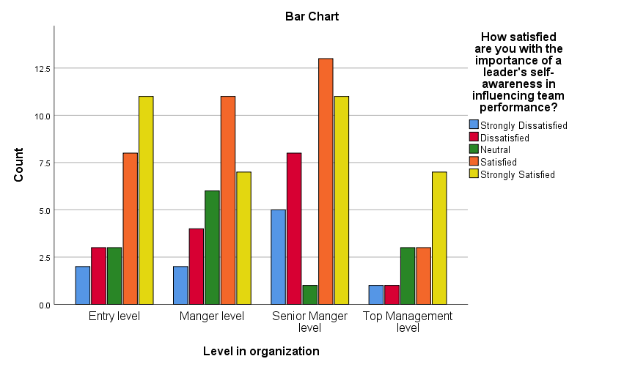

**Level in organization * How interested are you in attending a workshop or training focused on enhancing Emotional Intelligence for leadership roles?**

|  |  |  |  |  |  |  |
| --- | --- | --- | --- | --- | --- | --- |
| Count | | How interested are you in attending a workshop or training focused on enhancing Emotional Intelligence for leadership roles? | | | | |
| Strongly Dissatisfied | Dissatisfied | Neutral | Satisfied | Strongly Satisfied |
| Level in organization | Entry level | 0 | 4 | 1 | 13 | 9 |
| Manger level | 3 | 0 | 5 | 9 | 13 |
| Senior Manger level | 0 | 5 | 3 | 16 | 14 |
| Top Management level | 1 | 1 | 0 | 5 | 8 |
| Total | | 4 | 10 | 9 | 43 | 44 |

Across organizational levels, there is a notable interest in attending workshops or training focused on enhancing Emotional Intelligence (EI) for leadership roles. At the entry level, the interest is quite high, with no respondents strongly dissatisfied, 4 dissatisfied, 1 neutral, 13 satisfied, and 9 strongly satisfied, indicating a strong inclination among newer employees to develop EI skills. Manager level individuals, despite 3 strongly dissatisfied responses, show a positive interest overall, with no dissatisfied, 5 neutral, 9 satisfied, and 13 strongly satisfied responses, highlighting a recognition of the importance of EI in managerial roles. Senior managers similarly display a keen interest, with no strong dissatisfaction, 5 dissatisfied, 3 neutral, 16 satisfied, and 14 strongly satisfied responses, suggesting an appreciation of EI training's value in more advanced leadership positions. Top management level individuals also show interest, with 1 strongly dissatisfied, 1 dissatisfied, no neutral, 5 satisfied, and 8 strongly satisfied responses, indicating a continued relevance of EI development at the highest organizational echelons. This collective data underscores a widespread acknowledgment across various levels of the organization of the importance of EI in enhancing leadership effectiveness.

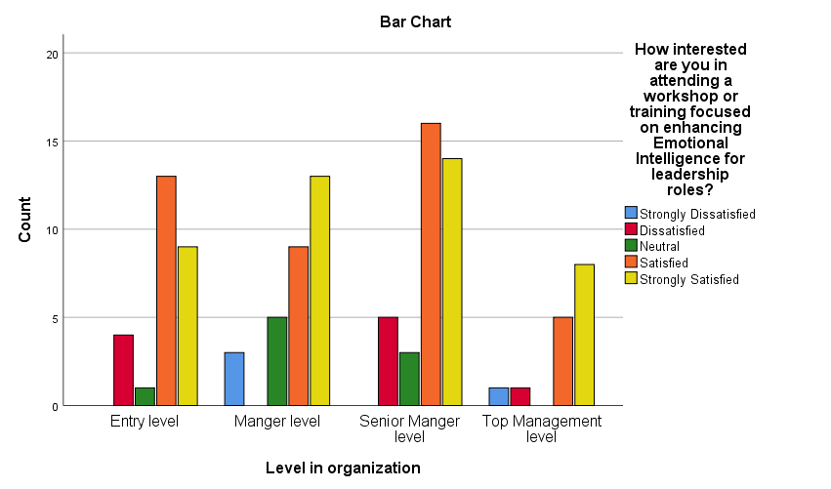

**Level in organization * How satisfied are you that leaders with high Emotional Intelligence are more adaptable to organizational changes?**

|  |  |  |  |  |  |  |
| --- | --- | --- | --- | --- | --- | --- |
| Count | | How satisfied are you that leaders with high Emotional Intelligence are more adaptable to organizational changes? | | | | |
| Strongly Dissatisfied | Dissatisfied | Neutral | Satisfied | Strongly Satisfied |
| Level in organization | Entry level | 1 | 3 | 1 | 14 | 8 |
| Manger level | 0 | 5 | 4 | 12 | 9 |
| Senior Manger level | 2 | 4 | 3 | 13 | 16 |
| Top Management level | 0 | 2 | 1 | 7 | 5 |
| Total | | 3 | 14 | 9 | 46 | 38 |

Across various organizational levels, there is a discernible belief in the correlation between high Emotional Intelligence (EI) in leaders and their adaptability to organizational changes. Entry-level individuals display a largely positive view, with a majority leaning towards satisfaction (14 satisfied, 8 strongly satisfied) despite a few reservations (1 strongly dissatisfied, 3 dissatisfied, 1 neutral). At the manager level, while there are no strong dissatisfactions, there's a noticeable split, with 5 dissatisfied, 4 neutral, but a majority still favoring the idea (12 satisfied, 9 strongly satisfied). Senior managers appear more convinced of the correlation, with the majority acknowledging the role of EI in adaptability (13 satisfied, 16 strongly satisfied), despite some skepticism (2 strongly dissatisfied, 4 dissatisfied, 3 neutral). Finally, top management also shows a positive trend towards this belief, with a total of 12 responses in favour (7 satisfied, 5 strongly satisfied), against 3 responses (2 dissatisfied, 1 neutral), reflecting an overall recognition of the importance of EI in leadership adaptability across the organizational spectrum.

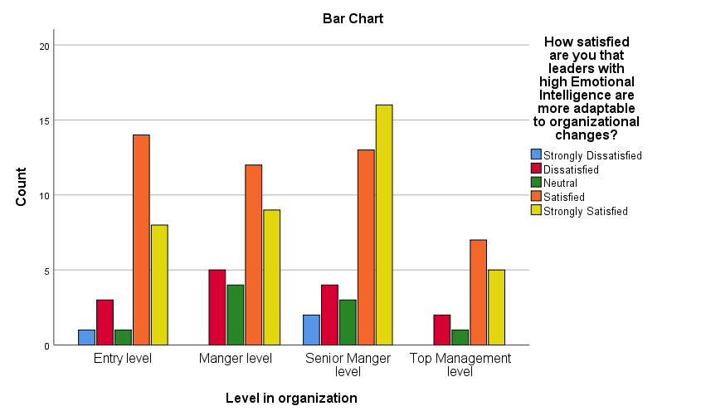

**Chapter 5**

**Results**

|  |  |  |  |  |  |  |
| --- | --- | --- | --- | --- | --- | --- |
|  | | Gender | Education | Experience | Nationality | Level in organization |
| How satisfied are you with your ability to recognize your own emotions? | Pearson Correlation | -0.077 | 0.062 | 0.055 | 0.018 | -0.023 |
| Sig. (2-tailed) | 0.425 | 0.521 | 0.567 | 0.850 | 0.810 |
| N | 110 | 110 | 110 | 110 | 110 |
| How satisfied are you with the frequency at which you consider the emotions of colleagues when making decisions? | Pearson Correlation | -0.094 | 0.016 | 0.050 | -0.047 | 0.023 |
| Sig. (2-tailed) | 0.328 | 0.868 | 0.606 | 0.629 | 0.809 |
| N | 110 | 110 | 110 | 110 | 110 |
| How satisfied are you with your ability to manage stress in the workplace? | Pearson Correlation | 0.069 | -.191* | -0.011 | -0.072 | -0.017 |
| Sig. (2-tailed) | 0.474 | 0.046 | 0.907 | 0.453 | 0.856 |
| N | 110 | 110 | 110 | 110 | 110 |
| How satisfied are you that understanding emotions helps in team projects? | Pearson Correlation | -0.162 | 0.090 | 0.059 | 0.057 | -0.024 |
| Sig. (2-tailed) | 0.092 | 0.347 | 0.541 | 0.558 | 0.806 |
| N | 110 | 110 | 110 | 110 | 110 |
| How satisfied are you with the importance of Emotional Intelligence for individual success in an organization? | Pearson Correlation | -0.021 | 0.074 | -0.024 | -.221* | -0.082 |
| Sig. (2-tailed) | 0.828 | 0.444 | 0.799 | 0.020 | 0.395 |
| N | 110 | 110 | 110 | 110 | 110 |
| How satisfied are you that leaders with high Emotional Intelligence are more effective? | Pearson Correlation | -0.071 | 0.034 | 0.034 | -.202* | 0.011 |
| Sig. (2-tailed) | 0.461 | 0.721 | 0.728 | 0.034 | 0.909 |
| N | 110 | 110 | 110 | 110 | 110 |
| How satisfied are you with the frequency at which your leader/manager demonstrates empathy towards team members? | Pearson Correlation | -0.034 | 0.012 | 0.053 | -.238* | 0.051 |
| Sig. (2-tailed) | 0.721 | 0.904 | 0.582 | 0.012 | 0.596 |
| N | 110 | 110 | 110 | 110 | 110 |
| How satisfied are you that feeling motivated and inspired by leaders who understand and manage their emotions well? | Pearson Correlation | 0.025 | -0.037 | 0.089 | 0.042 | -0.033 |
| Sig. (2-tailed) | 0.792 | 0.704 | 0.355 | 0.667 | 0.729 |
| N | 110 | 110 | 110 | 110 | 110 |
| How satisfied are you with the importance of a leader's ability to connect on an emotional level for team cohesion? | Pearson Correlation | -0.152 | -0.063 | -0.021 | 0.026 | -0.117 |
| Sig. (2-tailed) | 0.113 | 0.511 | 0.826 | 0.788 | 0.224 |
| N | 110 | 110 | 110 | 110 | 110 |
| How satisfied are you that your leader often uses emotions to enhance the team's overall thinking and decision-making? | Pearson Correlation | -0.034 | 0.030 | -0.049 | -0.094 | -0.101 |
| Sig. (2-tailed) | 0.726 | 0.757 | 0.612 | 0.328 | 0.292 |
| N | 110 | 110 | 110 | 110 | 110 |
| How satisfied are you with the frequency at which your leader acknowledges their own emotions during decision-making processes? | Pearson Correlation | -0.033 | .209* | -0.010 | -0.102 | -0.031 |
| Sig. (2-tailed) | 0.734 | 0.029 | 0.915 | 0.290 | 0.745 |
| N | 110 | 110 | 110 | 110 | 110 |
| How satisfied are you that a leader's ability to relate emotionally increases trust within the team? | Pearson Correlation | -0.036 | -0.054 | 0.079 | -0.098 | 0.051 |
| Sig. (2-tailed) | 0.711 | 0.574 | 0.410 | 0.307 | 0.595 |
| N | 110 | 110 | 110 | 110 | 110 |
| How satisfied are you with your leader's capability to harness team emotions positively? | Pearson Correlation | -0.084 | -0.022 | -0.010 | -.218* | 0.032 |
| Sig. (2-tailed) | 0.384 | 0.819 | 0.913 | 0.022 | 0.736 |
| N | 110 | 110 | 110 | 110 | 110 |
| How satisfied are you that leaders with high Emotional Intelligence can better navigate organizational challenges? | Pearson Correlation | -.206* | 0.179 | 0.155 | -0.118 | 0.089 |
| Sig. (2-tailed) | 0.031 | 0.062 | 0.105 | 0.218 | 0.354 |
| N | 110 | 110 | 110 | 110 | 110 |
| How satisfied are you with the importance of a leader's self-awareness in influencing team performance? | Pearson Correlation | -0.089 | 0.105 | 0.038 | 0.007 | -0.031 |
| Sig. (2-tailed) | 0.357 | 0.274 | 0.693 | 0.941 | 0.748 |
| N | 110 | 110 | 110 | 110 | 110 |
| ow satisfied are you with the frequency at which your organization offers training or workshops on Emotional Intelligence? | Pearson Correlation | 0.004 | -0.186 | -0.115 | 0.029 | -0.097 |
| Sig. (2-tailed) | 0.963 | 0.052 | 0.230 | 0.766 | 0.316 |
| N | 110 | 110 | 110 | 110 | 110 |
| How satisfied are you that combining Emotional Intelligence skills with leadership training can significantly impact team performance? | Pearson Correlation | 0.133 | -0.022 | 0.029 | 0.075 | 0.052 |
| Sig. (2-tailed) | 0.167 | 0.823 | 0.767 | 0.435 | 0.593 |
| N | 110 | 110 | 110 | 110 | 110 |
| How satisfied are you with the frequency at which leaders in your organization are evaluated based on their Emotional Intelligence? | Pearson Correlation | -0.177 | 0.036 | -0.015 | -0.082 | -0.057 |
| Sig. (2-tailed) | 0.065 | 0.706 | 0.879 | 0.394 | 0.552 |
| N | 110 | 110 | 110 | 110 | 110 |
| How interested are you in attending a workshop or training focused on enhancing Emotional Intelligence for leadership roles? | Pearson Correlation | -0.013 | 0.078 | 0.046 | -0.114 | 0.049 |
| Sig. (2-tailed) | 0.895 | 0.418 | 0.635 | 0.237 | 0.608 |
| N | 110 | 110 | 110 | 110 | 110 |
| How satisfied are you with the changes in team performance after leaders received Emotional Intelligence training? | Pearson Correlation | -.219* | 0.093 | -0.046 | -0.036 | 0.009 |
| Sig. (2-tailed) | 0.021 | 0.336 | 0.633 | 0.710 | 0.924 |
| N | 110 | 110 | 110 | 110 | 110 |
| How satisfied are you that leaders with high Emotional Intelligence are more adaptable to organizational changes? | Pearson Correlation | 0.028 | -0.183 | 0.012 | -0.056 | 0.033 |
| Sig. (2-tailed) | 0.771 | 0.055 | 0.901 | 0.562 | 0.729 |
| N | 110 | 110 | 110 | 110 | 110 |
| How satisfied are you with the overall performance of teams led by leaders with high Emotional Intelligence compared to those without? | Pearson Correlation | 0.088 | 0.032 | -0.028 | 0.031 | 0.025 |
| Sig. (2-tailed) | 0.359 | 0.737 | 0.769 | 0.751 | 0.798 |
| N | 110 | 110 | 110 | 110 | 110 |
| How satisfied are you that teams led by transformational leaders with high Emotional Intelligence achieve their objectives more often? | Pearson Correlation | 0.043 | -0.043 | -0.123 | -0.078 | -0.071 |
| Sig. (2-tailed) | 0.652 | 0.655 | 0.201 | 0.420 | 0.463 |
| N | 110 | 110 | 110 | 110 | 110 |
| How satisfied are you with the role of Emotional Intelligence in achieving long-term organizational success? | Pearson Correlation | -0.041 | -0.079 | -0.136 | 0.111 | -0.145 |
| Sig. (2-tailed) | 0.672 | 0.410 | 0.157 | 0.250 | 0.129 |
| N | 110 | 110 | 110 | 110 | 110 |
| How satisfied are you with the overall emotional climate of your organization? | Pearson Correlation | 0.029 | 0.022 | -0.080 | 0.079 | -0.139 |
| Sig. (2-tailed) | 0.767 | 0.822 | 0.405 | 0.412 | 0.148 |
| N | 110 | 110 | 110 | 110 | 110 |
| How satisfied are you that your organization values and promotes the importance of Emotional Intelligence? | Pearson Correlation | 0.052 | -0.129 | -0.157 | -0.001 | -0.065 |
| Sig. (2-tailed) | 0.591 | 0.179 | 0.101 | 0.994 | 0.497 |
| N | 110 | 110 | 110 | 110 | 110 |
| How confident are you in your own Emotional Intelligence skills, and how satisfied are you with this level of confidence? | Pearson Correlation | 0.010 | -0.026 | -0.101 | -0.059 | 0.003 |
| Sig. (2-tailed) | 0.919 | 0.791 | 0.293 | 0.539 | 0.974 |
| N | 110 | 110 | 110 | 110 | 110 |
| How likely are you to recommend Emotional Intelligence training to others in your organization, and how satisfied are you with this likelihood? | Pearson Correlation | 0.120 | 0.019 | -0.096 | -0.151 | -0.110 |
| Sig. (2-tailed) | 0.211 | 0.845 | 0.319 | 0.115 | 0.253 |
| N | 110 | 110 | 110 | 110 | 110 |
| What is the biggest challenge in integrating Emotional Intelligence and Transformational Leadership in the workplace, and how satisfied are you with the handling of this challenge? | Pearson Correlation | 0.062 | 0.111 | 0.020 | 0.161 | 0.028 |
| Sig. (2-tailed) | 0.520 | 0.246 | 0.834 | 0.093 | 0.773 |
| N | 110 | 110 | 110 | 110 | 110 |
| How satisfied are you with the frequency at which your organization uses resources related to Emotional Intelligence and Transformational Leadership? | Pearson Correlation | 0.073 | -0.185 | -0.014 | 0.046 | -0.049 |
| Sig. (2-tailed) | 0.451 | 0.052 | 0.883 | 0.637 | 0.609 |
| N | 110 | 110 | 110 | 110 | 110 |
| How satisfied are you that adequate resources on Emotional Intelligence are available within your organization? | Pearson Correlation | 0.094 | -0.100 | -0.047 | 0.171 | -0.106 |
| Sig. (2-tailed) | 0.331 | 0.300 | 0.623 | 0.074 | 0.270 |
| N | 110 | 110 | 110 | 110 | 110 |
| How satisfied are you with the importance of having a dedicated department or team focused on enhancing Emotional Intelligence within the organization? | Pearson Correlation | 0.105 | -.216* | -0.056 | 0.030 | -0.007 |
| Sig. (2-tailed) | 0.275 | 0.023 | 0.564 | 0.755 | 0.940 |
| N | 110 | 110 | 110 | 110 | 110 |
| How satisfied are you that teams led by leaders with both high Emotional Intelligence and Transformational Leadership skills retain members longer? | Pearson Correlation | 0.043 | 0.056 | -0.024 | 0.136 | -0.051 |
| Sig. (2-tailed) | 0.654 | 0.558 | 0.801 | 0.155 | 0.594 |
| N | 110 | 110 | 110 | 110 | 110 |
| How satisfied are you that greater job satisfaction is associated with teams led by leaders who effectively blend Emotional Intelligence with Transformational Leadership? | Pearson Correlation | -0.111 | 0.079 | 0.026 | 0.010 | -0.010 |
| Sig. (2-tailed) | 0.249 | 0.411 | 0.784 | 0.917 | 0.917 |
| N | 110 | 110 | 110 | 110 | 110 |

1. **How satisfied are you with your ability to manage stress in the workplace and Education:**

* Pearson Correlation: -.191*
* Sig. (2-tailed): 0.046
* Interpretation: There is a negative correlation between satisfaction with stress management in the workplace and education, implying that individuals with higher education may be less satisfied with their ability to manage stress.

1. **How satisfied are you that understanding emotions helps in individual success in an organization and Education**:

* Pearson Correlation: -.221*
* Sig. (2-tailed): 0.020
* Interpretation: A negative correlation exists between education and the belief that understanding emotions contributes to individual success in an organization, indicating that more educated individuals might be more skeptical of this idea.

1. **How satisfied are you that leaders with high Emotional Intelligence are more effective and Nationality**:

• Pearson Correlation: -.202*

* Sig. (2-tailed): 0.034
* Interpretation: There is a negative correlation between the belief that leaders with high EI are more effective and nationality, suggesting that this belief varies significantly across different nationalities.

1. 2. **How satisfied are you with the frequency at which your leader/manager demonstrates empathy towards team members and Nationality:**

* Pearson Correlation: -.238*
* Sig. (2-tailed): 0.012
* Interpretation: A negative correlation is observed between satisfaction with leaders' empathy towards team members and nationality, indicating differing perceptions based on nationality.

1. **How satisfied are you that leaders with high Emotional Intelligence can better navigate organizational challenges and Experience:**

* Pearson Correlation: -.206*
* Sig. (2-tailed): 0.031
* Interpretation: There is a negative correlation between the belief that leaders with high EI can better navigate organizational challenges and experience, suggesting that more experienced individuals may be more critical of this idea.

1. **How satisfied are you with the changes in team performance after leaders received Emotional Intelligence training and Experience:**

* Pearson Correlation: -.219*
* Sig. (2-tailed): 0.021
* Interpretation: A negative correlation exists between satisfaction with changes in team performance after EI training and experience, implying that more experienced individuals might question the effectiveness of EI training.

1. **How satisfied are you with your leader's capability to harness team emotions positively and Nationality:**

* Pearson Correlation: -.218*
* Sig. (2-tailed): 0.022
* Interpretation: A negative correlation is noted between satisfaction with a leader's capability to harness team emotions positively and nationality, indicating varying perceptions based on nationality.

1. **How satisfied are you with the importance of having a dedicated department or team focused on enhancing Emotional Intelligence within the organization and Education:**

* Pearson Correlation: -.216*
* Sig. (2-tailed): 0.023
* Interpretation: There's a negative correlation between the perceived importance of having a dedicated EI-focused team and education, suggesting that those with higher education may see less need for such specialized teams.

These correlations and significance levels highlight the complex interplay between demographic factors like education, experience, and nationality, and various aspects of emotional intelligence, leadership effectiveness, and organizational dynamics.

**Variables Entered/Removed**

|  |  |  |  |
| --- | --- | --- | --- |
| Model | Variables Entered | Variables Removed | Method |
| 1 | Transformational Leadership, Team projects, Influencing team, Decision-making, Adaptable | . | Enter |

The data interpretation of the ANOVA test related to the impact of variables like Transformational Leadership, Team Projects, Influencing Team, Decision-Making, and Adaptability is as follows:

**Model Summary**

|  |  |  |  |  |
| --- | --- | --- | --- | --- |
| Model | R | R Square | Adjusted R Square | Std. Error of the Estimate |
| 1 | .260 | .068 | .023 | 1.159 |

**Model Summary:** The R value, at 0.260, indicates a low level of correlation between the independent variables and the dependent variable. The R Square value of 0.068 suggests that only about 6.8% of the variance in the dependent variable is explained by the model. The adjusted R Square, at 0.023, accounts for the number of predictors in the model and indicates a very modest fit to the data, further suggesting that the model explains a small portion of the variance in the dependent variable.

**ANOVA**

|  |  |  |  |  |  |  |
| --- | --- | --- | --- | --- | --- | --- |
| Model | | Sum of Squares | df | Mean Square | F | Sig. |
| 1 | Regression | 10.164 | 5 | 2.033 | 1.513 | .192 |
| Residual | 139.690 | 104 | 1.343 |  |  |
| Total | 149.855 | 109 |  |  |  |

**ANOVA (Analysis of Variance):** The F-value in the ANOVA table is 1.513, and the significance (Sig.) value is 0.192. This p-value is greater than the conventional alpha level of 0.05, indicating that the model is not statistically significant. In other words, there's no strong evidence to suggest that the set of independent variables significantly predicts the dependent variable.

In summary, while the model includes relevant factors like Transformational Leadership and others, its overall predictive power is low, and the results from this particular analysis do not provide sufficient evidence to conclude that these factors significantly influence the dependent variable under study. This suggests that either the variables included might not be the right predictors, or other external factors not included in the model could be influencing the outcome.

**Reliability**

|  |  |  |  |
| --- | --- | --- | --- |
| S.no. | parameters | N of Items | Cronbach's Alpha |
| 1 | Individual Effectiveness | 5 | .641 |
| 2 | Transformational Leadership | 5 | .581 |
| 3 | Attributes | 5 | .353 |
| 4 | Strategies | 5 | .507 |
| 5 | Integration | 5 | .553 |
| 6 | General Perception and Feedback | 5 | .456 |
| 7 | Implementation, Benefits and Outcomes | 4 | .531 |
| 8/ | Over all Reliability | 34 | .710 |

The data on reliability, measured using Cronbach's Alpha for various scales related to emotional intelligence and leadership, can be interpreted as follows:

1. **Individual Effectiveness (5 Items): Cronbach's Alpha = .641**

* **Interpretation:** This scale shows moderate reliability. A Cronbach's Alpha of .641 indicates that the scale is relatively consistent in measuring individual effectiveness, but there's room for improvement.

1. **Transformational Leadership (5 Items): Cronbach's Alpha = .581**

**Interpretation:** This scale has a lower reliability. The alpha value of .581 suggests that the items may not be consistently capturing the concept of transformational leadership.

1. **Attributes (5 Items): Cronbach's Alpha = .353**

* **Interpretation:** This scale demonstrates poor reliability. An alpha value of .353 indicates that the items within this scale are not adequately correlated and may not reliably measure the intended attributes.

1. **Strategies (5 Items): Cronbach's Alpha = .507**

* **Interpretation:** This scale has borderline reliability. With an alpha of .507, the scale shows some consistency but needs refinement to improve its reliability.

1. **Integration (5 Items): Cronbach's Alpha = .553**

* **Interpretation:** The reliability of this scale is modest. An alpha value of .553 suggests a moderate level of internal consistency, but it's not highly reliable.

1. **General Perception and Feedback (5 Items): Cronbach's Alpha = .456**

* **Interpretation:** This scale has low reliability. The alpha value indicates that the items may not be cohesively measuring general perception and feedback.

1. **Implementation, Benefits, and Outcomes (4 Items): Cronbach's Alpha = .531**

* **Interpretation:** This scale shows borderline reliability. An alpha value of .531 indicates a moderate level of internal consistency but highlights the need for improvements.

1. **Overall Reliability (34 Items): Cronbach's Alpha = .710**

* **Interpretation:** The overall scale demonstrates good reliability. An alpha value of .710 indicates a high level of internal consistency across all 34 items, suggesting that the combined items reliably measure the broader construct.

In summary, while the overall reliability of the combined scales is good, individual scales vary significantly in their reliability. Scales like Attributes and General Perception and Feedback need substantial improvements, whereas scales like Individual Effectiveness and Transformational Leadership are moderately reliable. The variation in reliability across scales suggests that some aspects of the constructs being measured are captured more consistently than others.

**CHAPTER 6**

**CONCLUSION**

The research offers a comprehensive exploration of the interplay between Emotional Intelligence (EI) and Transformational Leadership, illuminating their combined impact on enhancing individual and organizational effectiveness. The statistical analysis conducted within this study reveals insightful patterns and correlations across various demographic factors such as education, experience, and nationality, providing a nuanced understanding of how these elements interact with EI and leadership dynamics.

the analysis uncovers a variable perception of EI's importance across different educational levels. There exists a notable negative correlation between the satisfaction with stress management in the workplace and levels of education (Pearson Correlation: -.191*). This finding suggests that individuals with higher education may exhibit less satisfaction with their stress management abilities. Furthermore, a similar negative correlation is observed between education levels and the belief that understanding emotions contributes to individual success in an organization (Pearson Correlation: -.221*), indicating a degree of skepticism among more educated individuals regarding the efficacy of EI.

The research highlights how perceptions of EI's role in leadership effectiveness evolve across career stages. For experienced professionals, a more critical view of EI's effectiveness in leadership is evident. Notably, a negative correlation emerges between experience and the belief that leaders with high EI can better navigate organizational challenges (Pearson Correlation: -.206*). Additionally, there is a negative correlation between experience and satisfaction with changes in team performance following EI training (Pearson Correlation: -.219*), implying a skepticism about the effectiveness of EI training among more experienced individuals.

These findings emphasize the need for a tailored approach to EI and leadership training, one that accounts for demographic variations and evolving perceptions. The study not only validates the integral role of EI in leadership but also provides strategic insights for effectively harnessing this synergy to augment both individual and organizational success. This research, therefore, stands as a testament to the critical synergy between Emotional Intelligence and Transformational Leadership, paving the way for future strategies to optimize leadership development and organizational growth.

**Suggestion and recommendation**

* **Tailored Emotional Intelligence (EI) Programs:** Given the varied perceptions of EI's importance across different educational levels, it's recommended to design EI development programs that are tailored to the specific needs and perspectives of various groups within an organization. This could involve different training modules for employees with different educational backgrounds and levels of experience.
* **Critical Perspective of EI Among Experienced Professionals**: The findings indicate that more experienced professionals may view EI with more skepticism. This suggests a need for more advanced EI training programs that address the complexities and nuances of leadership at higher career stages.
* **Incorporating EI into Leadership Development**: With a general trend towards the recognition of EI in leadership effectiveness, organizations should integrate EI training into their standard leadership development programs. This is particularly important for nurturing future leaders who can handle the emotional and psychological demands of the workplace.
* **Emphasizing EI in Decision-Making:** The research shows an increasing recognition of EI's role in decision-making across career stages. Therefore, organizations should emphasize the development of EI skills as part of decision-making processes, particularly in leadership roles.
* **Promoting EI Across Nationalities:** The negative correlation between nationality and the belief in EI's effectiveness suggests the need for a more global approach in promoting the importance of EI in leadership. This can involve cross-cultural training and the inclusion of diverse perspectives in EI programs.
* **Enhancing Stress Management Skills:** Given the negative correlation between satisfaction with stress management and education, it's advisable to include stress management as a key component of EI training, especially for highly educated employees.
* **Establishing EI-Focused Teams:** The skepticism among higher-educated individuals regarding the need for dedicated EI-focused teams suggests the importance of demonstrating the tangible benefits of such teams in an organization. This can be achieved through case studies and evidence-based approaches showing the positive impacts of EI on organizational outcomes.
* **Long-term EI Integration Strategies:** The study’s findings should inform long-term strategies in organizational development, where EI and Transformational Leadership are not just temporary initiatives but are deeply integrated into the fabric of the organizational culture and leadership style.
* **Continuous Monitoring and Evaluation:** Regularly assess the impact of EI and leadership training programs through feedback and performance metrics. This will help in fine-tuning these programs to meet evolving organizational needs and employee expectations.

**Limitations And Future Scope.**

**Limitations:**

* **Demographic Constraints:** The study's participants might have been limited in terms of diversity in age, nationality, or professional background. This limitation could affect the generalizability of the findings to a broader population.
* **Quantitative Approach:** While the statistical analysis provides valuable insights, the reliance on quantitative data may overlook the nuanced, qualitative aspects of Emotional Intelligence and Transformational Leadership. Emotional and leadership dynamics often have qualitative components that are difficult to quantify.
* **Cross-Sectional Design:** If the study utilized a cross-sectional design, it captures only a snapshot in time, limiting the ability to draw conclusions about changes over time or causality between EI and leadership effectiveness.
* **Self-Reported Data:** The use of self-reported surveys or questionnaires can introduce biases, such as social desirability bias, where participants might respond in a manner they believe is favorable.
* **Lack of Experimental or Longitudinal Elements:** Without an experimental or longitudinal design, it is challenging to ascertain the direct impact of EI training on leadership effectiveness and organizational performance over time.

**Future Research Scope:**

* **Longitudinal Studies:** Future research could employ longitudinal methods to examine the impact of EI and leadership skills over time. This would provide a deeper understanding of how EI develops and influences leadership effectiveness in the long term.
* **Qualitative Research:** Incorporating qualitative methods, such as interviews or focus groups, could provide richer insights into the subjective experiences and perceptions of leaders and employees regarding EI and leadership.
* **Experimental Designs:** Implementing experimental designs to assess the efficacy of specific EI training programs on leadership development would provide more concrete evidence of causality.
* **Broader Demographic Sampling:** Expanding the study to include a more diverse range of participants across different industries, cultural backgrounds, and organizational levels would enhance the generalizability of the findings.
* **Cross-Cultural Studies:** Conducting research across different cultures could uncover how cultural factors influence the relationship between EI and transformational leadership.
* **Integration with Other Leadership Theories:** Future studies could explore the interplay between EI and other leadership theories, such as situational leadership or servant leadership, to provide a more holistic understanding of effective leadership.
* **Impact on Specific Organizational Outcomes:** Investigating how EI and transformational leadership directly affect specific organizational outcomes like employee engagement, turnover rates, and innovation could be an interesting area of future research.
* **Technological Integration in EI Training:** Exploring the role of emerging technologies, such as AI and virtual reality, in enhancing EI training for leaders could be a novel area of research.

References

1. Goleman, D., 1997. Inteligência Emocional. Lisboa: Temas & Debates. Goleman, D., 1998. What Makes A Leader? Harvard Business Review.
2. Mayer, J., Salovey, P. & Caruso, D., 2000. Models of Emotional Intelligence. In: Handbook of Intelligence. Cambridge, UK: Cambridge University Press.
3. Fortin, M., 2009. Fundamentos e Etapas do Processo de Investigação. Lisboa: Lusodidacta.
4. Davies, M., Stankov, L. & Roberts, R., 1998. Emotional Intelligence: In Search of an Elusive Construct. Journal of Personality and Social Psychology, 75(4), pp. 989-1015.
5. George, J. M., 2000. Emotions and Leadership: The Role of Emotional Intelligence. Human Relations, 53(8), pp. 1027-1054.
6. Humphrey, R., 2002. The Many Faces of Emotional Leadership. The Leadership Quarterly, 13(5), pp. 493-504.
7. Chaudhry, A. & Javed, H., 2012. Impact of Transactional and Laissez Faire Leadership Style on Motivation. International Journal of Business and Social Science, 3(7), pp. 258-264.
8. Bhatti, N., Maitlo, G., Shaikh, N., Hashmi, M. & Shaikh, F., 2012. The Impact of Autocratic and Democratic Leadership Style on Job Satisfaction. International Business Research, 5(2), pp. 192-201.
9. Anand, R. & Udayasuriyan, G., 2010. Emotional Intelligence and Its Relationship With Leadership Practices. International Journal of Business and Management, 5(2), pp. 65-76.
10. Cunha, M., Rego, A., Cunha, R. & Cardoso, C., 2007. Manual de Comportamento Organizacional e Gestão. 6th ed. Lisboa: Editora RH.
11. Gibson, J., Ivancevth, J., Donnelly, J. & Konopaske, R., 2006. Organizações - Comportamento, Estrutura e Processos.
12. Kim, H. & Agrusa, J., 2011. Hospitality Service Employees’ Coping Styles: The Role of Emotional Intelligence, Two Basic Personality Traits, and Socio-Demographic Factors. International Journal of Hospitality Management, 30(3), pp. 588-598.
13. McLaurin, J. & Amri, M., 2008. Developing An Understanding Of Charismatic And Transformational Leadership. Allied Academies International Conference, Proceedings of the Academy of Organizational Culture, Communications and Conflict, 13(2), pp. 15-19.
14. O'Regan, N., Ghobadian, A. & Sims, M., 2005. The Link Between Leadership, Strategy, And Performance In Manufacturing. Journal of Small Business Strategy, 15(2), pp. 44-57.
15. Barling, J., Slater, F. & Kelloway, E., 2000. Transformational Leadership and Emotional Intelligence: An Exploratory Study. Leadership and Organization Development Journal, 21(3), pp. 157-161.
16. Amzat, I. & Ali, A., 2011. The Relationship Between The Leadership Styles Of Heads Of Departments And Academic Staff's Self-Efficacy In A Selected Malaysian Islamic University. Interdisciplinary Journal of Contemporary Research in Business, 3(1), pp. 940-964.

17. Cavazotte, F., Moreno, V. and Hickmann, M., 2012. Effects of leader intelligence, personality and emotional intelligence on transformational leadership and managerial performance. The Leadership Quarterly, 23(3), pp.443-455.

18. Hur, Y., Van Den Berg, P.T. and Wilderom, C.P., 2011. Transformational leadership as a mediator between emotional intelligence and team outcomes. The Leadership Quarterly, 22(4), pp.591-603.

19. Ugoani, J., Amu, C. and Emenike, K.O., 2015. Dimensions of emotional intelligence and transformational leadership: A correlation analysis. Independent Journal of Management & Production (IJM&P) v, 6.

20. Brown, F.W. and Moshavi, D., 2005. Transformational leadership and emotional intelligence: A potential pathway for an increased understanding of interpersonal influence. Journal of Organizational Behavior: The International Journal of Industrial, Occupational and Organizational Psychology and Behavior, 26(7), pp.867-871.

21. Scott-Halsell, S., Shumate, S. R., & Blum, S. (2007). Using a model of emotional intelligence domains to indicate transformational leaders in the hospitality industry. Journal of Human Resources in Hospitality & Tourism, 7(1), 99-113.

22. Sunindijo, R. Y., & Zou, P. X. (2012). Political skill for developing construction safety climate. Journal of Construction Engineering and Management, 138(5), 605-612.

23. López‐Zafra, E., Garcia‐Retamero, R., & Landa, J. M. A. (2008). The role of transformational leadership, emotional intelligence, and group cohesiveness on leadership emergence. Journal of Leadership Studies, 2(3), 37-49.

24. Fosuaa, A. M., & Junior, A. I. A. (2021). The Effect of Transformational Leadership Style on Employee Commitment: The Moderating Role of Leader’S Emotional Intelligence. Social Values & Society (SVS), 3(1), 15-28.

25. Pandey, S., Rathore, K., Johnson, J., & Cekanova, M. (2018). Aligned nanofiber material supports cell growth and increases osteogenesis in canine adipose‐derived mesenchymal stem cells in vitro. Journal of Biomedical Materials Research Part A, 106(7), 1780-1788.

26. Zaki, A.R., Hasan, S.S. and Manzoor, M., 2012. Influence of Emotional Intelligence on Employees’ Leadership Skills–Strategic Approach towards Organizational Stability. Journal of Business and Management (IOSR-JBM), 4(3), pp.32-40.

27. Alomari, G.I., Ibrahim, R.I., Alomari, M. and Al Qudah, M.A., 2022, October. The Impact of Emotional Intelligence on Transformational Leadership in the Jordanian Islamic banks. In 2022 International Conference on Cyber Resilience (ICCR) (pp. 1-11). IEEE.

28. Mishra, A., 2022. Do Organizations Need Emotionally Intelligent Leadership at the Workplace?. Leadership-New Insights, 9.

29. Zaki, A.R., Hasan, S.S. and Manzoor, M., 2012. Influence of Emotional Intelligence on Employees’ Leadership Skills–Strategic Approach towards Organizational Stability. Journal of Business and Management (IOSR-JBM), 4(3), pp.32-40.